Volume 45, Issue 4

April .19!

IIONAL PUBLICATION OF THE ASSOCIATED LOCKSMITHS OF AMERICA, INC

Being part of something really BIG.

**Government, universities, hospitals, corporations and more rely on institutional locksmiths.**

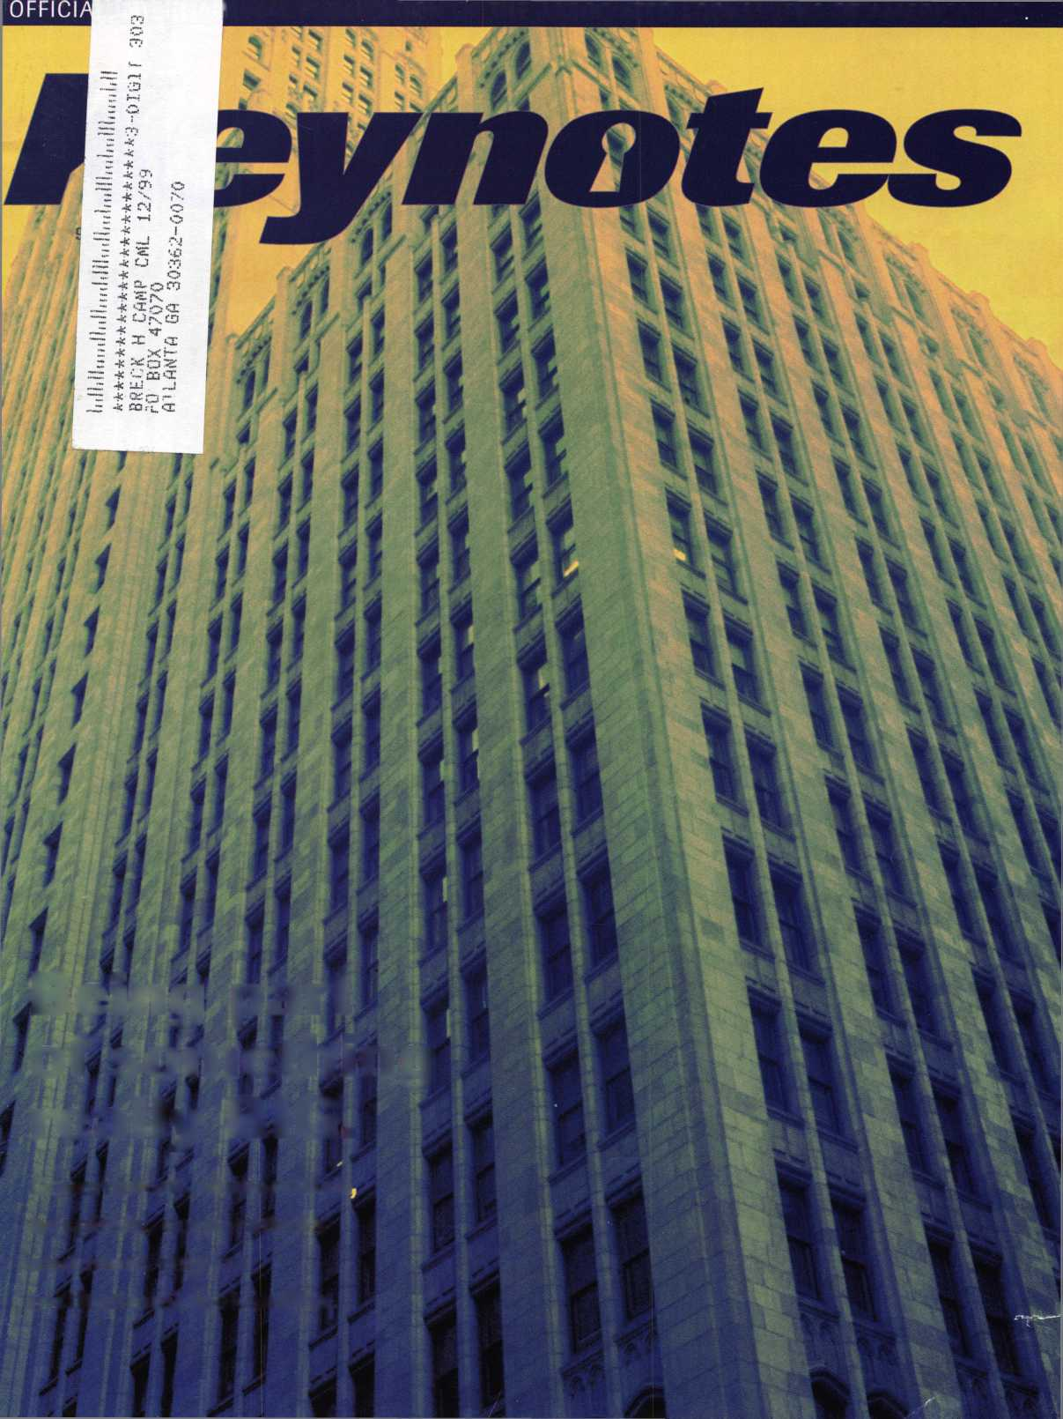

You wouldn’t dream of leaving your success to chance. You know that making it in the safe and vault industry requires hard work, continual improvement of techniques, and constant research of the latest products and tools.

Your best bet to excel in all these areas is

SAFETECH ’99 where you can save your luck for the casinos, and get down to business viewing the latest products, talking with the manufacturers and training in the latest methods of safe and vault technology.

Make your plans now to attend SAFETECH ’99 May 3-8, 1999 in Las Vegas, NV.

Contact:

Safe and Vault Technicians Association

3003 Live Oak Street Dallas, TX 75204 214.827.7233

email: [convtion@anet-dfw.com](mailto:convtion@anet-dfw.com)

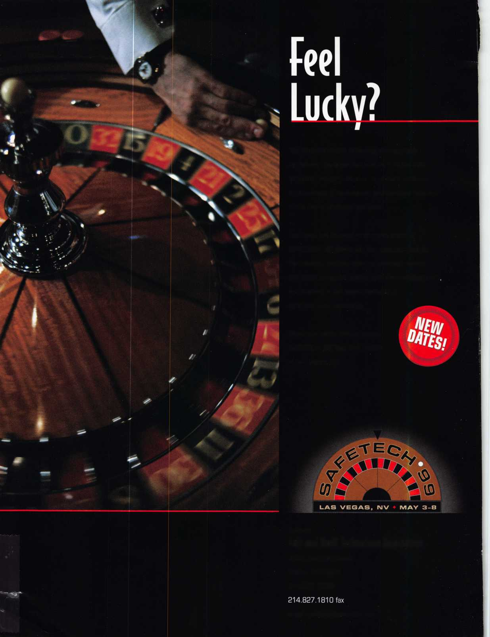

* Super bearing construction.
* Superior rigidity and accuracy.
* Shipped with carbide cutter.
* 2 year parts and labor warranty.
* Increased cut rates:

Laser made 8 sec

Standard mode 12 se

Bi Axial 6 pin 17 se

* New Medeco Autoswing head option.

f~ \

L J0QSHB

Id GO GO BO O30BB

**WEAR EVE PROTECTION**

* Up to 800 built-in manufacturer depths and spaces.
* Works with most popular Master key systems.
* Serial port to communicate with user systems.
* Repeatable accuracy of l/1000th inch.
* Dependable heavy duty construction.
* 1 year parts and labor warranty.
* Cuts Medeco™ High Security keys with angled cuts.

The ITL 9000 was built by locksmiths — we know what you wanted so we built it. When a new lock comes out you add the space and depths immediately. No Mechanical adjustments. All sealed and prelubricated bearings.

ITL -9000

OSGOOD

SGDGOOD

QGDGDfDD

OtSBSOQ

WEAR EYE PROTECTION

* Uses either 12 or 120 volts.
* All manufacturer depths and spaces built in.
* Heavy duty construction.
* 12 month warranty.
* Built in Master key System.

**TOOLS LIMITED**

— **Now Distributed Throughout USA, Canada & Australia** —

2639B Progressive Way • Abbotsford, BC Canada V2T6H8  
USA: 562-699-0060 • Canada: 604-852-8904 • Canada Fax: 604-852-8938 • Toll Free: 1-888-264-6627

V*, U w, - %1 ■T

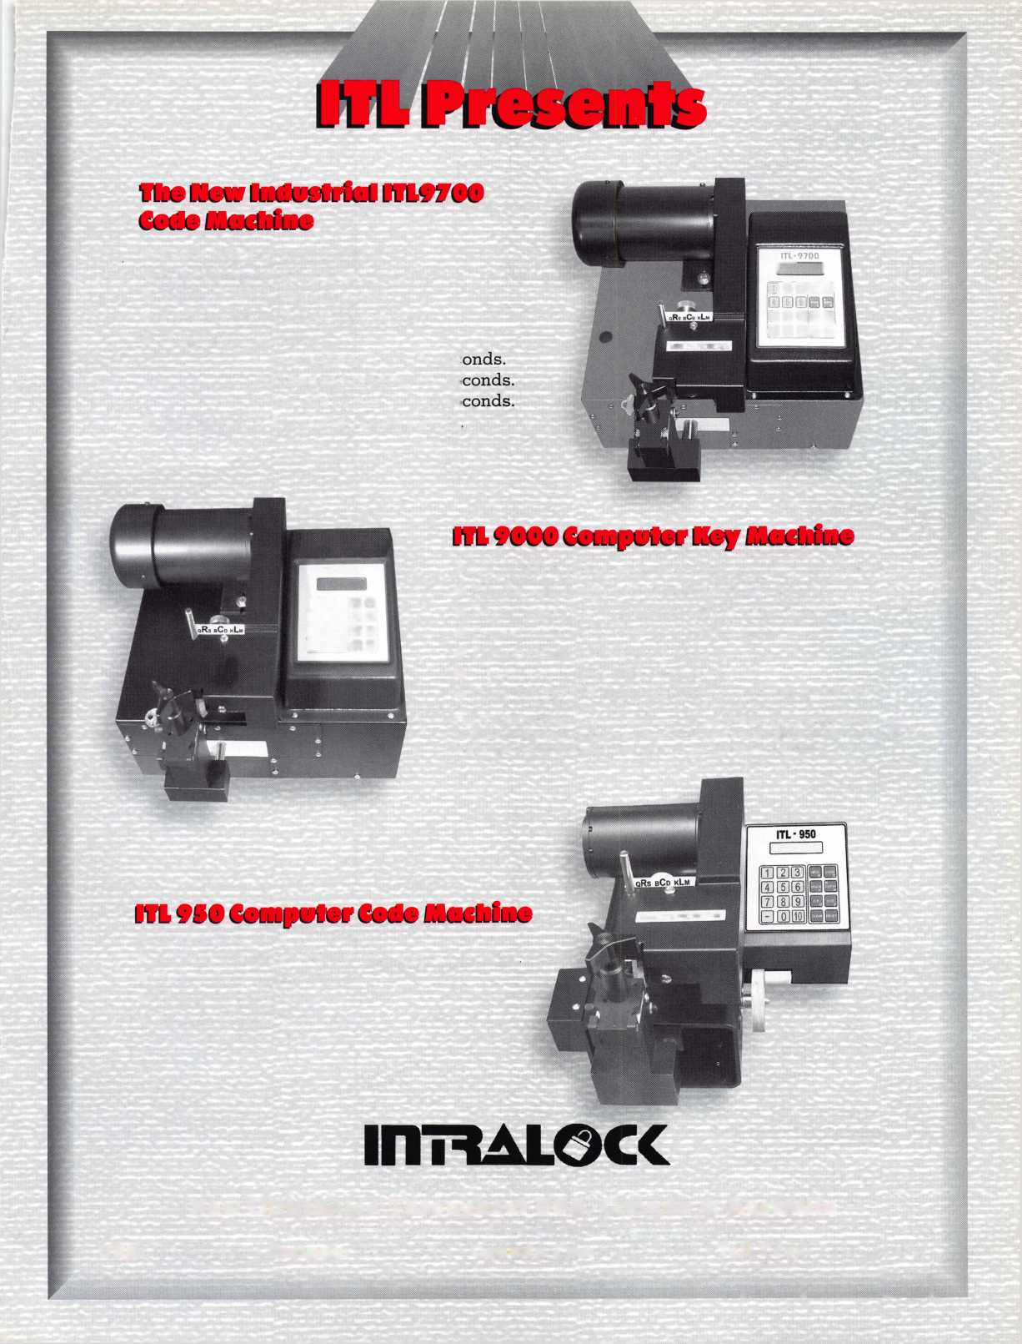

Contents

Features

**April**

8

President’s Journey

By Dallas Brooks

15

The Locksmith Business Card, Part II

The conclusion of our look at one of your most valuable marketing assets, the business card!

By Michael A. Ferrill

Sometimes You Fall Into Something Good

Who would have thought a locksmith position at a university would lead to the career of a lifetime? Not Shelly Finkelstein!

Learn how he became the institutional locksmith for the University of Maryland-Baltimore.

By Claire Cohen, CML

What is Institutional Locksmithing

The “Island Locksmith” explores the concept of institutional locksmithing, then pays a visit to the locksmith at Nantucket Cottage Hospital.

By Michael A. Ferrill

22

Learning From the Ground Up

He’s a high flyer and never even leaves the ground. Meet Michael Rummage, the locksmith at the Cincinnati Northern Kentucky Airport!

By Patanya Johnson

The Cover:

They’re in schools, medical complexes, hotels, factories, airports, industrial parks and more. They are institutional locksmiths-a career choice that is not for everyone, but great for some... maybe even you?

Art direction Valerie Rowe

Graphic design Lori Brennan

New Security for Storefront Doors

An alternative solution for securing storefront doors. Introducing GardLok 300!

By Paul Chandler, CRL

27

Schlage Knob Cylinder Removal Without a Key

A delicate procedure, eloquently demonstrated by our author.

By Sal Dulcamaro, CML

31

Personal Security Devices from Americorp

An array of products you wouldn’t believe!

From anti-mugging devices to a baby potty-guard.

By Sal Dulcamaro, CML

40

Legislative Update

His wings take him where laws are being passed, bills are introduced and amendments are made. ALOA’s “Legal Eagle,” Tim McMullen has the low down on legislation that could affect you.

By Tim McMullen

-J

Keynotes

**April 1999**

LEDtronics packs its bags (for a very short trip); Saf T Lok makes headway in gun safety.

10

Upcoming Events

Security Marketplace

12

14

Applicants for Membership

Scheduled for clearance May 1.

43

Authors in this Issue

44

Backpage



34

Classifieds

35

Ad Index

36

Associate Members

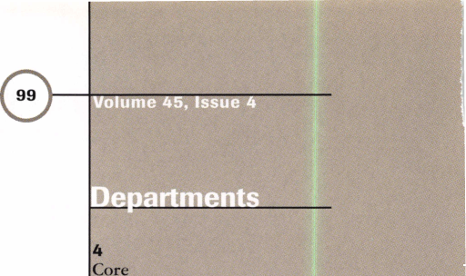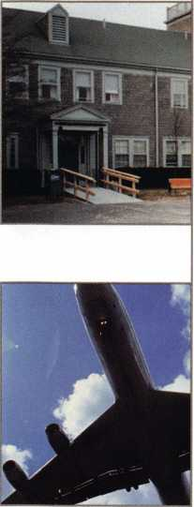

|  |  |
| --- | --- |
| Editor | Mike Emery [keynotes@anet-dfw.com](mailto:keynotes@anet-dfw.com) |
| Technical Editor | David Lowell, CML, CMS [david@aloa.ioffice.com](mailto:david@aloa.ioffice.com) |
| Communications Assistant | Patanya Johnson |
| Editorial Advisor | John D. Cannon, CML [jdcannon@worldnet.att.net](mailto:jdcannon@worldnet.att.net) |
| Advertising Sales | Marvin Diamond  Native American Journal Co. (770) 998-7056 [thediamonds@mindspring.com](mailto:thediamonds@mindspring.com) |
| Contributing Authors | Jerome V. Andrews, CML  Paul Chandler, CRL  Claire Cohen, CML  Brian Costley, CML, CMS  Bob De Weese, CPL  Ray D’Adamo, CML  Sal Dulcamara, CML  James Glazier, CML  Daniel Graffeo, CRL, CMS Wayne Gurnee, CRL  A.J. Hoffman, CML  Ken Holmlund, CRL  Ray Lusk, CML  Mark Ohno  Randy Simpson, CML  Robert Stafford, CPL  Dave Thielen, CML |
| ALOA Professional Staff | |
| Executive Director | Charles W. Gibson, Jr., CAE [charlie@aloa.ioffice.com](mailto:charlie@aloa.ioffice.com) |
| Operations Manager | Mary May  [mary@aloa.ioffice.com](mailto:mary@aloa.ioffice.com) |
| Receptionist | Heather Reynolds |
| Mail Room Coordinator | Jeff Jordan |
| Comptroller | Kathy J. Romo |
| Finance Coordinator | Janelle Vergara |
| Meetings Manager | Jessica Smith [jessica@aloa.ioffice.com](mailto:jessica@aloa.ioffice.com) |
| Meetings Coordinator | Janelle Vergara |
| Government Affairs Manager | Tim McMullen  [tim@aloa.ioffice.com](mailto:tim@aloa.ioffice.com) |
| PRP/Education Manager | David Lowell, CML, CMS [david@aloa.ioffice.com](mailto:david@aloa.ioffice.com) |
| Education Assistant | Ashley Spencer |
| Membership Manager | Brandon Durrett  [brandon@aloa.ioffice.com](mailto:brandon@aloa.ioffice.com) |
| Membership Coordinator | Jackie Arnett [jackie@aloa.ioffice.com](mailto:jackie@aloa.ioffice.com) |
| Chapters & Regional | |
| Associations Liaison | Tim McMullen  [tim@aloa.ioffice.com](mailto:tim@aloa.ioffice.com) |

Executive

m©dbcC| Medeco Security Locks

is a Grand Master Key Sponsor of the ALOA ’99 Convention and Security Expo.

Additional contact information for the ALOA Board and most Keynotes authors are available through “Locksmith Search”' on the ALOA website- [www.aioa.org](http://www.aioa.org) or by contacting the ALOA office at 3003 Live Oak Street; Dallas, TX 75204; [800)532-2562; FAX [214) 827-1810; e-mail [aloa@aloa.org](mailto:aloa@aloa.org).



Mission Statement: The Associated Locksmiths of America, Inc. is dedicated to enhancing the professionalism, education and ethics among locksmiths and those in related sectors of the physical security industry. With approximately 10,000 members in the United States, Canada and the freeworld, ALOA is poised to help members obtain the knowledge, the strength, and the confidence to perform their role in the physical security field with pride and dignity. But it is only through active involvement and participation that ALOA can fully achieve its potential-and can help members to achieve theirs.

Policies: Keynotes® is the official publication of the Associated Locksmiths of America, Inc. (ALOA). Keynoted acts as a moderator without approving, disapproving, or guaranteeing the validity or accuracy of any data, claim, or opinion appearing under a byline or obtained or quoted from an acknowledged source. The opinions expressed by the authors do not necessarily reflect the official views of ALOA. Also, appearance of advertisements and new products or service information does not constitute an endorsement of products or services featured by the Association. The Association does not accept responsibility for the inaccuracy of any data, claim, or opinion appearing in this publication, due to typographical errors on the part of the authors, Association staff or its agents. Editor’s Note: This publication is designed to provide accurate and authoritative information in regard to the subject matter covered. It is provided and disseminated with the understanding that the publisher is not engaged in rendering legal or other professional services. If legal advice and other expert assistance is required, the services of a competent professional should be sought.

Authors’ Payment: Payment for eligible submissions to Keynotes will be based on the following criteria: topic, time spent and past contributions. Authors who regularly submit to Keynotes are generally paid a higher rate. The latter is especially true of authors who write to fit specific editorial needs and submit said copy by Keynotes deadlines. As a general guideline: Average payment for a 750 word, business or ‘light’ technical article would be $200. Payment for a 1500 word article involving significantly higher time and research efforts would be $400.

Payment will not be offered for articles submitted by ALOA employees or members of the ALOA Board of Directors [unless material is of a technical nature), nor for articles submitted by a company that promote that company’s products or services. ALOA reserves the right not to pay for articles submitted by an individuals) that promote a particular company’s products or services.

Disclaimer: The Associated Locksmiths of America, Inc., [ALOA), reserves the right to refuse any article for any reason. Additionally, ALOA reserves the right to edit, amend or modify any article submitted for publication in order to preserve technical accuracy, clarity, fairness or grammatical correctness. ALOA will make the best efforts to notify the author of any changes. The extent of ALOA's liability for any article or information contained therein will be a notice of correction or retraction in the next possible issue.

Keynotes® [ISSN 0277 0792) is published monthly except for the combined June/July issue by The Associated Locksmiths of America, Inc., 3003 Live Oak St., Dallas, TX 75204-6186. Telephone: [214) 827-1701; FAX [214) 827-1810; e-mail [aloa@aloa.qrg](mailto:aloa@aloa.qrg). Subscription rates for members-$15.00 per year. Second class postage paid at Dallas, Texas. POSTMASTER: Send address changes to: Keynotes, 3003 Live Oak St., Dallas, TX 75204-6186. © Copyright 1999, All rights , reserved. No part of the contents may be reproduced or reprinted in any form without prior written permission of the publisher.

3oard



President

Dallas C. Brooks [334) 826-8990

Secretary

John D. Cannon, CML [703) 960-6413

Directors, Northeast

James H. Glazier, CML [301) 831-5454 John C. Magee, III

1. 845-3434 William L. Young, CML
2. ) 647-5042

Directors, Southeast

Jeffrey S. Nunberg, CML, CMS [305) 324-8800 Donald R. Rule, CML [601) 324-2658

Directors, North Central

Mark E. Blum, CML, CPS [517) 482-5809 John J. Greenan [773) 486-2030

Director, South Central

Randy L. Simpson, CML [713) 780-7026

Directors, Southwest

Gordon Racine, CML [719) 384-4707 John I. Shandy, CML [303) 774-9791

Director, Northwest

Scott Henke, CRL, CPS [907) 248-3785

Director, Associate Members

Judd Penske [800) 634-5465

Non-voting Directors

Jerome V. Andrews, CML [216) 642-3900 Steve G. Engel, CML, CPP [920) 731-5400

David^Lowell.CML, CMS [800) 532-2562 Breck H. Camp, CML [770) 455-6244 Henry H. Printz, CML [973) 538-2737 Leonard J. Passarello, CPL [416) 752-7210 Edwin Toepfer, RL [416) 225-5589

Chairmen of International Affairs

Laurence P. Mills/Australia [129) 958-0445 Hans Mejlshede, CML/Europe FAX [453) 139-1004

Past Presidents

1995-1997 David Lowell, CML, CMS 1993-1995 Breck Camp, CML 1991-1993 Henry Printz, CML 1989-1991 Evelyn Wersonick, CML, CPS 1987-1989 Leonard Passarello, CPL 1985-1987 Joe Jackman, CML 1983-1985 Stanley Haney, CPL 1981-1983 Louis LaGreco, CPL 1979-1981 John Kerr, RL 1977-1979 Clifford Cox, CML 1974-1977 Charles Hetherington 1972-1974 Gene Laughridge 1970-1972 William Dutcher, RL 1968-1970 Constant Maffrey, RL 1966-1968 Harold Edelstein, RL 1964-1966 William Meacham 1962-1964 Robert Rackliffe, CPL 1960-1362 Edwin Toepfer, RL 1956-1960 Ernest Johannesen



**April 1999**

Keynotes

“LEDs have been instrumental to the security world for at least 10 years already...LEDs produce the invisible light source so one doesn’tevenknow they’re being videotaped...”

core

• Movin’ on up

The security world recently underwent a slight transition. One of its chief proponents of security sensors, LEDtronics has moved. Actually, it’s moved just a few blocks from its original location on Pacific Coast Highway in Torrance, Calif, to 23105 Kashiwa Court.

Sure, it seems like a minor change but the company maintains that its relocation will enhance its production of LEDs (or light emitting diodes). These same diodes function as status indicators on electronic devices and provide infra-red light for surveillance cameras.

“LEDs have been instrumental to the security world for at least 10 years already,” says Jordon Papanier, Marketing Manager of LEDtronics. “They’ve had an impact. After all, with infra red cameras, LEDs produce the invisible light source so one doesn’t even know they’re being video taped at night. The camera picks up a much sharper picture with this type of light source.”

According to Papanier the new facility will encompass 63,000 square feet and will provide three times the manufacturing space of its previous location.

“The move was made to keep up with our growth pattern, which has averaged to be about 25 percent a year,” he says. “The LED market has become wider and with new technology, more applications have opened up. In order to keep up with the increased demand, we obviously needed a bigger building.”

Papanier also says that the future for LED-based products appears to be very bright (no pun intended). On the horizon are more products to help security professionals including a safety vest with 3M reflective strips and LEDs along the side for night wear.

—Mike Emery

• We’ve got another winner!

Back in February, our Back Page contest asked for readers’ Top Five reasons they should go to Cincinnati. The winner of this creative exercise was drawn among all the entrants and will receive two free tickets to the ALOA ’99 Banquet.

Well, we had some awesome responses (many of which earned an ALOA ’99 Way Cool T-shirt), but the lucky contestant was none other than Roger Weitzenkamp.

His number-one reason for wanting to go to ALOA ’99 in Cincinnati was: “Humidity makes my hair curl nicely.” Thanks for all the entries! See you in Cincinnati (with or without curly hair)!

• Welcome to Paradox

Paradox Security Systems, a Canadian based manufacturer of electronic security equipment is setting up shop in the United States.

A new distribution office in Los Angeles will maintain a fully stocked warehouse and conduct technical seminars and technical support for dealers.

The company (which turns 10 years old this year) already has 40 distribution offices in 40 countries. The newest division will be known as Paradox USA and offer a full line of electronic security products, including control panels, space protection systems, wireless systems, access systems and card readers.

The address for Paradox USA is 5853 Uplander Way in Culver City, Calif. 90230. It can be contacted at (310) 670-8880 or (310) 670-8853 via fax. Email can be sent to [saleusa@paradox.ca](mailto:saleusa@paradox.ca).

Keynotes

April 1999

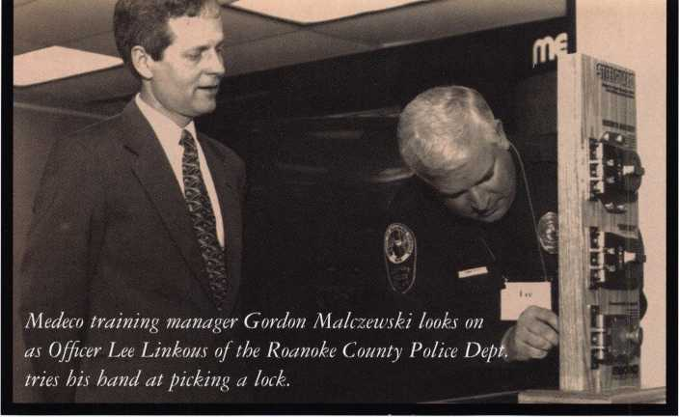

• Crime Busters

It’s always refreshing to see members of the law enforcement world and security industry working together. Combined, the two parties can make life rather difficult for would-be thieves and burglars. With that in mind, Medeco High Security Locks developed the “Lock-Out on Crime” program.

The program is conducted in a “train the trainer” format. Its conducted by profes­sionals among Medeco s staff and is designed to instruct crime prevention officers on the various techniques that thieves use to break into homes. It also gives tips on how to safeguard against such potential break-ins.

“Lock-Out on Crime” recently kicked off at Medeco s headquarters in Salem, Va.

In attendance were 50 plus Virginia officers. In a recent press release from Medeco, the

response to the program was generally positive.

Sergeant Rick Arrington, President of the Southwest Regional Division of the Virginia Crime Prevention Association, was quoted as saying, “With Medeco s expertise, officers are able to stay abreast of techniques for access control and become familiar with advances in locking mechanism technology.”

At press time, Medeco is planning to offer “Lock Out on Crime” to crime prevention officers throughout the Unites States. In the meantime, Medeco’s “Security Tips” booklet is currently available and offers detailed tips on how citizens can increase their safety. Interested parties can call (800) 6MEDECO for more information.

— Mike Emery



Gun SafT

No one can deny the value of gun safety. With that, Saf T Lok, Inc. has been seeing a rise in its clientele requesting combination gun locks.

Most recently, the company was called upon to equip police departments in Boston, Key Biscayne, Fla. and at Harvard University. Aside from these regional agencies, the Lawmen’s Safety Supply of Raleigh, NC and Columbia, SC has signed on as a distributor for law enforce­ment customers in the eastern region of the United States.

The gun locks (for use on revolvers and semi-automatic handguns) are part of the gun itself and have a touch sensitive combination.

In addition to being used by several police and security offices, the SafT Lok gun locks have even been endorsed by the Institute for Police Research (a division of the International Union of Police Associations).

Best and HID go to school

Soka University will see some changes in the 21st century. No, male and female students will not be allowed to room together, nor will beer be added to the cafeterias selection of beverages. Instead, proximity locks will secure over 2,000 doors on its new Aliso Viejo campus.

The college based in southern California is getting a security overhaul of sorts as Best Access Systems’ battery powered proximity locks (utilizing HID’s proximity technology) are being installed on campus. Also, 500 HID ProxPro readers are being integrated into the security system as specified by the Schatz Consulting Group.

According to Bret Schatz, president of the aforementioned security consul­tants, Best Access and HID collaborated on a proximity read mortise lockset that will be used on the campus. This will allow students to use a single HID proximity card to access every door in every facility on the Aliso Viejo campus.

**April 1999Keynotes** | **5**

• Distributor earns certification

Ademco Distribution Inc. (ADI), distributor of security, low voltage and cabling products, recently earned its ISO 9002 certification for quality management and customer satisfaction. ADI is the only security distributor in the U.S. to earn this distinction.

The requirements of the ISO 9000 Quality Assurance System Standards is set by the Inter­national Standards Organization. The organization defines the elements needed to ensure effective quality management and customer service, by companies to make the list of “preferred suppliers.” A company must pass 20 sections of standards, practice complete quality assurance and provide customer satisfaction in order to gain certification As a third party, the American Quality Assessors (AQA), audits each company to make sure they carry out the policies and procedures as stated by the company while providing a service to customers.

The ISO 9002 certification relates to Sales, Purchasing, Inspection, Shipping, Delivery and Installation. ADI earned the certification in its network of both U.S. and Canadian Shipping Centers as well as its U.S. Regional Distribution Centers.

In order to maintain the certification ADI must continue to pass six month audits by AQA and follow its Quality Policy in doing business

Europe leads the way in quality assurance and ISO 9000 certifications, but many U.S. companies are adapting to this way of doing business and earning certification. A few thousand companies in the U.S. have earned certification, but only a small portion are in the distribution industry.

**WE WANT TO SEE**

...Out in the ALOA Open, that is. The ALOA Open Golf Tournament, sponsored by Yale Security Group Inc., and benefitting the ALOA Scholarship Foundation, will be held Wednesday, July 28, 1999, during the ALOA '99 Convention and Trade Show.

Entry includes breakfast, green fees, a golf shirt and hat, and

the evening dinner event. Everyone who enters is eligible to win

one of many incredible prizes, including golf clubs, equipment

and clothing. And everyone who enters the tournament, or purchases a

$100 banquet ticket is automatically entered in the grand prize drawing —

A TRIP FOR TWO TO THE PGA CHAMPIONSHIP!

A $150 tax-deductible donation to the ALOA Scholarship Foundation reserves your spot. But SPACE IS LIMITED! Send your name, address, phone number and ALOA Member Number (if applicable) right away to:

**SIGN ME UP!**

ALOA '99 Open Golf Tournament 3003 Live Oak Street Dallas, TX 75204

**Tickets to the PGA Championship**

Medina Country Club in Chicago *courtesy Rosemont Convention Center*

**Round-trip Airfare for Two**

*courtesy Allstate Insurance*

**Four Nights at the Rosemont Hyatt Regency**

*courtesy Hyatt*

**Rental Car**

*provided by ALOA*

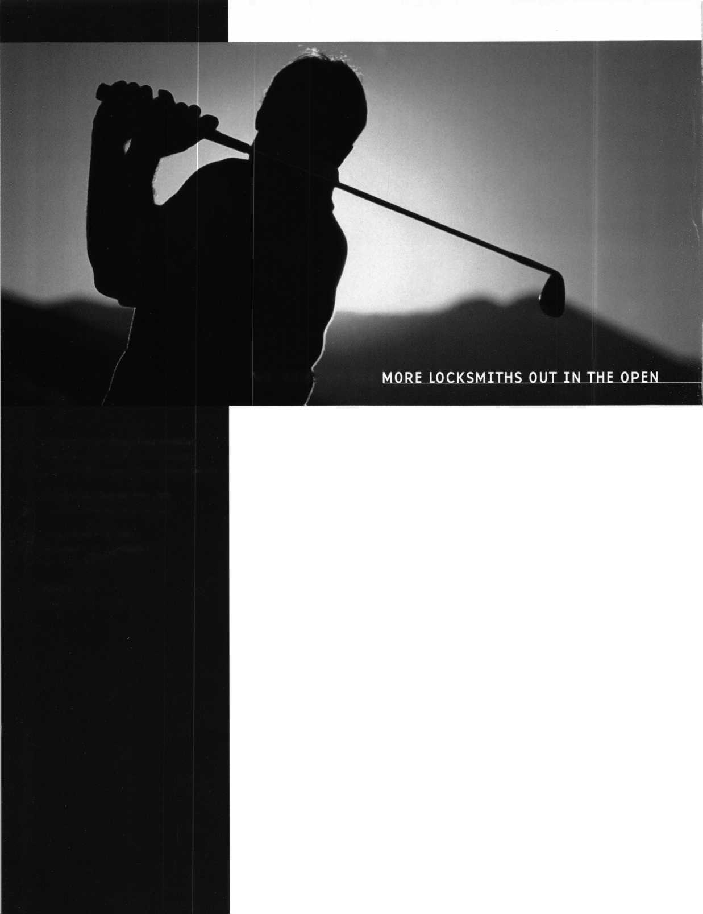

* execs

Black and Decker recently announced the election of **Manuel A. Fernandez** to its

Board of Directors.

Strattec Security Corporation made some changes to its management ranks.

**Harold M. Stratton llv** formerly president and chief executive officer was elected to chairman of the board and will retain the title of CEO.

**John G. Cahill,** formerly executive vice president and chief financial officer was elected president and chief operating officer.

**Patrick J. Hansen,** formerly corporate controller was elected vice president and chief financial officer.

**Michael R. Elliot,** formerly vice president of sales and marketing was elected to the new position of vice president of Global Market Development.

Sensor Electronics Corporation announced the appointment of **Peter Boriskin** to the position of eastern regional field application engineer for its Access Control Division.

Detex Corporation has announced two key promotions at senior management levels. **Phillip N. Haselton,** who has served as president of Detex Corporation has been named chairman and chief executive officer. Also, **John H. Blodgett,** Vice President and General Manager was promoted to the position of President and chief operating officer.

**Rick Stevens** has been appointed to the position of vice president of Paradox USA.

* regions

**The South Jersey Locksmiths Assocaition** will hold its second annual “Swap Show,” Sunday, April 25. For more details, call (609) 767-4977, (609) 894-0805 or (609) 939-6373.

**The Greater Philadelphia Locksmiths Association** will hold a Beef and Beer Social on April 24. Tickets are **$20** and available by calling (609) 665-1311 or (609) 662-4494.

**The Wyoming Locksmiths Associ­ation** will hold its Spring Meeting and Trade Show, May 14, 15 and 16. A special Strattec class will be given by Joy Skowron and Bob Walkling on the 15th. For details, call (307) 587-3035.

ALOAs **Wisconsin Indianhead Chapter** will hold its 2nd Annual Swap Meet and Family Picnic, Saturday June 26 from 11 am to 3 pm. For more details, call

(715) 832-4207 between 8 am and 4:30 pm (CDT) or email [chapter@safenlock.com](mailto:chapter@safenlock.com).

(Editors note: Would you like to see your regional association’s activities represented in **Keynotes?** Just fax all correspondence to 214- 827-1810 or email to: [keynotes@anet-dfw.com](mailto:keynotes@anet-dfw.com).)

• prp

CRLs

Karl Gruber, **St. Johns, MI** James Hancock, **Austin, TX** Ron Kay, **Arvada, CO** Henry J. Lachausse, **Austin, TX** Bernard Shutes, Jr., **Three Rivers, MI**



• obituaries

ALOA sends its condolences to the family and friends of **Mr. Bannie Therrell,**

a longtime member who passed away at the age of 77. He was the strength behind the Therrell Alarm company and resided in Hewitt, Texas.



Do you need Electrified

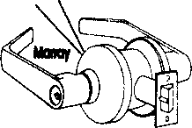

0 y Trim  
l' Locks

**o**

Hinges

Panic Devices  
Access Hardware  
Custom Modifications?

You Need To Call Marray

1-800-500-1449

Marray Enterprises, Inc., is an after-market modifier of locks, hinges, and panic devices. Located in the Silicon Valley of California, Marray uses precise computer controlled machin­ing to modify name brand hardware like Schlage, Von Duprin, Arrow, Baldwin, Bommer, PBB hinges and more! If you are looking for superior products with the best warranty, pricing, delivery and availability, call Marray. Your first source for UL listed & modified hardware.

m

Marray ***enterprises, inc.***

**At** Marray, we’re not just modifiers, we’re Master Hardware Modifiers™  
1128 Walsh Ave*, Santa Clara, CA 95050* [www.fTHJrray.com](http://www.fTHJrray.com)

**April 1999**

***Keynotes***

It’s almost time! ALOA ’99 in Cincinnati is just around the corner. It’s hard to believe isn’t it? I mean, last year’s awesome show in Nashville seems as if it was just yesterday.

Nonetheless, it’s safe to say that this year’s event is shaping up to be one to remember. Of course, there will be traditional convention events to look forward to including the ALOA Open, the Banquet, the Membership Meeting and, of course, the grand opening of the trade show floor. This year’s show will have its share of new things as well.

For starters, we’re offering a First-Timer’s Orientation on Sunday, July 25 from 7:00 AM to 7:45 AM. If you’ve never been to an ALOA Convention before, we know that things may seem confusing. With that in mind, this orientation will answer all of your questions.

We’ll also be raffling off a 1999 Chevy Astro Cargo Van. Some of the exhibitors will be donating tools to make this a ready-to-go mobile shop for the lucky winner. Every adult registrant will receive a ticket and additional tickets will be sold by the ALOA Scholarship Foundation. You must be present to win, so you’ll want to stick around for this.

I mentioned the ALOA Open earlier, but this year, all participants (as well as anyone who purchases a $100 dinner ticket) will be entered into a drawing to attend the PGA Tournament.

Among other new items at ALOA ’99 are the CML Breakfast and Bonus Sunday-an extra day of classes.

This year’s Annual Membership Meeting will also have some changes. Now that members will vote by proxy, there will be no voting at the meeting. This will allow people more time to bring questions to the board for discussion. This also allows meeting attendees time to enjoy a special presentation on new products by various exhibitors. This presentation will follow the formal meeting.

For those of you who haven’t already made plans to join us, don’t delay! I can’t think of another experience as beneficial or as fun for anyone in our profession.

See you there!

Dallas C. Brooks President

**April 1999**

1L Keynotes



Kwok-kei Leung

Henry Raymond

Toshihiro Asa no __________

Stewart Levine, CML Mary Ohmit, CPL

Charles Robertson, CML

Yuriko Yanai

Jack Hobin, CPL

Allen Konrath

Salvatore Dulcamara, CML_

Myeong-Rae Cho

William Neff, CML

David Lowell, CML

Thomas Freehling, CML __

Dana Barnum, CML

John Heckman, CML

Jeanne Lodge, CML

Barry Leas, CRL ____________

J Thomas Hood, CML

Roy Renderer, CML

Danny Rudd, CPL

John Elliott, CML

Lawrence F. Smith, Jr., CML

Larry ]Narnic\<f CML

James Watt, CML

Robert Carroll, CPL

Diana Barnum, CRL

Barbara Watt David M A Federico Robert DeWeese, CPL

Jim Williams

Anthony Ramunno, CML

Jerome Cohen, CML

Eugene Altobella

Charles Cole, CML

Elvis Hammerschmidt, CPL__

Marian Swann, CRL

John Dorsey, CPL

D Michael Lee, CPL

James Fowler, CML David Harris, CML

John Kerr, RL

Ronald Heidzig

Joseph Ferrero, CML

James Cawby, CML

Philip Rovenolt, CPL Michael Robinson, CRL _ Brian Reetz Walter Lascar,^L Thomas Vandersteen, CML__

_39

_38

_35

_32

_32

_31

_30

_30

_28

_26

_25

_24

_24

_24

_24

_23

_23

_22

_22

_22

.22

.22

.21

.21

.21

.19

.19

.18

.18

18

.18

.18

17

17

16

16

16

16

16

15

15

Best.

William Grant,

Gary Teams, CPL William McElheney, CML

Rex Parmelee, RL 14

James Gruber, CRL__14

Keizo Takahashi 14

Robert Duman, CML 14 Russell Fuller, CRL14 Daniel Landry14 Edwin W Scott13 Peter Gauthier, CPL 13 Frank Hartung, CML 13 Jon Griswold, CML13 Paul Souber 13 Richard Sievers 13

Steven Spiwak, CRL 13

Robert Rodocker, CRL12 Keiryu Tsukishiro12 Rolando Bouza12 Lonnie McKinney, CML 12 James Brickler, CRL12

Joe Lee, CRI 12

Eric Veal12

Herbert Dusenberry, CML 11

Raymond Lusk, CML11 Robin Horsley11

John Engel, CRI _11

Donald Shiles11 Thomas Demont, CML10

Ernest Wright 10

William Wickward, CML10 Lester Brodsky 10 Joseph Whitaker, CPL10 Dale Knowles, CPL10 William Lee 10

What do I get?

When you recruit 10 members, you receive a handsome blue blazer with a President's Club crest. For each additional five members you recruit, you receive a lapel pin with gold-filled numbers, indicating your recruiting successes.

You also get the satisfaction of knowing that you are helping your association, helping your industry grow, and you are helping fellow locksmiths achieve success,

How do I get started?

Contact the ALOA office for a supply of applications (800) 532-ALOA or FAX (214) 827-1810. One President's Club credit is awarded for each new applicant. Credit is awarded only after the membership application is approved. However, the credit will apply for the period in which the application is received. Failure to identify yourself as the sponsor on the application form at the time it is submitted to ALOA for processing will forfeit any credit.

*AL0A Board of Directors not eligible for membership in the President's Club.

You can earn membership in this prestigious recruiting just 10 new members for ALOA. *Any ALOA member may participate.

club by



Upcoming

Events



[Deptl

Indicates ALOA ACE Class Indicates PRP Sitting

1999

APRIL

9-11

ALOA Spring Board Meeting

Hilton Atlanta Airport & Towers

Atlanta, GA

Contact: Mary May

1. 827-1701

(214) 827-1810 fax

email: [mary@aloa.ioffice.com](mailto:mary@aloa.ioffice.com)

11

ALOA PRP Sitting Butte, MT

Montana Locksmith Association Contact: Walter P. Cooney, CML (406) 782-0125 (406) 782-0125 fax

11

ALOA PRP Sitting Oakland, CA Clark Security Products Contact: Terri Burges (619)974-5273 (619) 974-5284 fax

12-16

MBA Training DoD Combination Locks Nicholasville, KY (888) 622-5495

1. 16

Access Control:

Understanding the Technology ASIS International Reno, NV Contact: ASIS (703)519-6200

17-18

MBA Training Professional Safe Drilling Nicholasville, KY (888)622-5495

20-21

ASTM Meeting on Security Systems and Equipment Seattle, WA

Contact: Cynthia Blackwell (610)832-9737

20-24

American Security Show & Educational Conference Disneyland Hotel Anaheim, CA 800-844-8545 714-579-3508 (fax)

24-25

18th Annual Crossroads of America Antique Locks, Keys and Restraint Show Indianapolis, IN Contact: Pete Schaefer (317)926-3232 (317) 251-3951 (fax)

MAY

3-8

SAFETECH ’99 Las Vegas, NV (214)827-7233

7-8

DHI Continuing Professional Development Seminar Toronto, Canada (703) 222-2010

8

ALOA PRP Sitting Las Vegas, NV SAVTA Contact:

David M. Lowell, CML, CMS

(214)827-7233

(214) 827-1810 fax

14-16

Spring Meeting/Annual Trade Show Wyoming Locksmiths Association Contact: Fran McCumber 1026 Alger Ave.

Cody, WY 82414

15

MBA Training Expert Lock Picking Nicholasville, KY (888) 622-5495

16

MBA Training Expert Lock Picking Nicholasville, KY (888)622-5495

JUNE

2-6

ELF Convention Hotel Haarlem Zuid Haarlem, Netherlands +31-23-537-69-07 (fax)

5-10

DHI Technical School Seminar Arizona State University Tempe, AZ Contact:

(703)222-2010

6

5 th Annual Locksmith Swap Meet and Olympics Quality Inn Hotel Lyndhurst, NJ Contact: Jeff Sitar (973) 777-0620

11-12

DHI Continuing Professional Development Seminar Renaissance Cottonwoods Resort Scottsdale, AZ (703) 222-2010

19

MBA Training Safe Deposit Locks Nicholasville, KY (888) 622-5495

20

MBA Training Time Locks Nicholasville, KY (888) 622-5495

26

2nd Annual Swap Meet & Family Picnic Wisconsin Indianhead Chapter Valley Builders Eau Claire, WI (715)832-4207

JULY

10-15

DHI Technical Schools Arizona State Univ Tempe, AZ Contact:

(703) 222-2010

22-25

DHI Chapter Leadership

Conference

The SunBurst Resort

Phoenix, AZ

Contact:

(703) 222-2010

25-31

ALOA ’99 Security Expo Cincinnati, OH (800) 532-2562

AUGUST

i

ACE Classes

ALOA ’99 Security Expo Cincinnati, OH (800)532-2562

6-7

DHI Continuing Professional

Development

TBD

Seattle, WA (703) 222-2010

6-7

ACE Classes Albuquerque, NM New Mexico Locksmiths Assoc. Contact: Steve Highland (505) 268-8663 (505) 268-8802 fax

8

**^** ALOA PRP Sitting Albuquerque, NM New Mexico Locksmiths Assoc. Contact: Steve Highland (505) 268-8663 (505) 268-8802

19-20

ACE Classes SERLAC Orlando, FL

Contact: Austin Curry, CRL (813) 837-8488 (813) 839-1825 fax

22

ALOA PRP Sitting Baltimore, Md.

Clark Security Products Contact: Terri Burges (619)974-5273 (619) 974-5284 fax

22

**f** ALOA PRP Sitting Orlando, FL SERLAC

Contact: Austin Curry, CRL (813) 837-8488 (813) 839-1825 fax

27-30

MLA’s London Convention Contact: Dave Stokes 139 Wood Street Walthamstow,

London, E17 3LX 01144181 520 7450

SEPTEMBER

1. 19

GPLA Annual Convention Philadelphia, PA Contact:

Jack Magee (registration)

(609)845-3434

Don Amole (booth space)

1. 288-5588

[www.gpla.org](http://www.gpla.org)

1. 19

TAOL’s 26th Anniversary Convention International Plaza Hotel and Conference Centre Toronto, Ontario (888) 272-8265 (416) 321-5115 fax

1. 19

Distributors Show Inn of the Ozarks,

Eureka Springs, AR

Ozark Professional Locksmith Assoc.

Contact: Betty Gray

(501) 524-3660 day

(918) 427-1066 evenings or

Bill or Janis Reves

(501) 631-0017 day

(501) 631-6406 evenings

OCTOBER

1-3

Jo-Van National Trade Show and Educational Seminar

(416) 752-7249

10

ALOA PRP Sitting Burbank, CA Clark Security Products Contact: Terri Burges (619)974-5273 (619) 974-5284 fax

NOVEMBER

6-7

Yankee Security Convention Sturbridge Host Hotel Sturbridge, MA **800**-**209-8266**

2000

APRIL

6-9

MLANJ 2000 Annual Convention Somerset, NJ (973) 267-8884 (973) 538-2248 fax [www.mlanj.org](http://www.mlanj.org)

MAY

1-6

SAFETECH 2000 Birmingham, AL (214) 827-7233

JULY

23-30

ALOA 2000 Las Vegas, NV (214) 827-1701

2001

MARCH

28-April 1

MLANJ 2001 Annual Convention Somerset, NJ (973) 267-8884 (973) 538-2248 fax [www.mlanj.org](http://www.mlanj.org)

JULY

15-22

ALOA 2001 Security Expo Baltimore, MD (800) 532-2562

2002

JULY

21-28

ALOA 2002 Security Expo Rosemont, EL (800) 532-2562

1. 18

DHI 24th Annual Convention and Exposition Dallas, TX Contact: DHI (703) 222-2010

17

**^** ALOA PRP Sitting Penn/Ohio Locksmith Assoc. Coraopolis, PA Contact: Martha R. Eggler

1. 676-8464 (216) 267-2511 fax

***Keynotes***

**April 1999**

**Keynotes** readers get the last word...

Every year Keynotes awards the “Author of the Year” to the locksmithing scribe who has gone beyond the call of duty  
when writing and submitting articles to Keynotes. Since our readers are a vital part of the magazine’s success, we’ve  
decided to let this year’s award be decided by “Readers Choice!”

Review the list of articles below from April ’98 to March ’99 and select your favorite author. Feel free to comment  
on what influenced your author selection; and the stories you found to be the most valuable, and why.

Thank-you from Keynotes for your participation; and from our authors for your support and helpful feedback.



1998

APRIL

Low Tech Products

Sal Dulcamara, CML

Inside 3M

Steven Spiwak, CRL

A Conversation with Rovey

Paul Chandler

The Evolution of the Security Industry, Part III

Steven Spiwak, CRL

Servicing Mul-T-Lok Heavy Duty Padlocks

Sal Dulcamara, CML

Biometrics

Steven Spiwak, CRL

MAY

So You Can Do Safe Work Too?

James Jeffries

Impressioning Single Bitted GM Keys

Steven Spiwak, CRL

Promoting Your Business

Steven Spiwak, CRL

Reconstructive Surgery for Safes, Part I

Daniel Graffeo, CRL, CMS

The Ethics of “Do Not Duplicate”

Sal Dulcamara, CML

HPC’s In-A-Minute Auto Lock Decoder

Sal Dulcamara, CML

The Importance of Home Security

Steven Spiwak, CRL

JUNE/JULY Bi Lock

Steven Spiwak, CRL

A-I’s #J-50 Simplex 1000 Installation Jig

Sal Dulcamara, CML

InstaCode

Sal Dulcamara, CML

The Sliding Magnalock

Greg Perry, CML, CPS

Powerlever

Paul F. Chandler, CRL

Reconstructive Surgery for Safes, Part II

Daniel Graffeo, CRL, CML

AUGUST Key Master

Sal Dulcamara, CML

To Master Key or Not?

Jerome Andrews, CML

A Delicate Balance

Steven Spiwak, CRL

SEPTEMBER

Who Are the Crime Prevention Experts?

Sal Dulcamara, CML

Point/Counterpoint:Licensing

Sal Dulcamara, CML and Kathy Zaniolo, CPL

Unusual Locks, Unusual Methods

Sal Dulcamara, CML

The Role of the Professional Locksmith

Steven Spiwak, CRL

Behind the Scenes with ALOA Continuing Education

Paul Chandler, CRL

OCTOBER

Auto Lock Tools

Sal Dulcamara, CML

AutoTel Tells All

Sal Dulcamara, CML

High-Tech Ignitions

Fred Kosloske

The Chrysler 8-Cut Kit

Sal Dulcamara, CML

The Other Automotive Customer

Buddy Logan

GM Progression 101

Steven Spiwak, CRL

NOVEMBER

Is There a Drill Doctor in the House?

Sal Dulcamara, CML

A Simple, But Effective Tool (to Solve a Major Problem)

Steven Spiwak, CRL

Specialty Screwdrivers from Keedex

Sal Dulcamara, CML

The Singertech Neutralizer Tool

Sal Dulcamara, CML

New Life for an Old Install

Greg Perry, CML, CPS

Reading the Fine Print of Responsibility in Limited Warranties

Paul F. Chandler, CRL

Customer Feedback

Claire Cohen, CML

DECEMBER

Schlage Enters the 1-Core Market

A. J. Hoffman, CML

Image Vault Digital Security

James H. Glazier, CML

Is There a Niche for You In the Booming CCTV Market?

Paul F. Chandler, CML

Introducing e.Primus

Paul F Chandler, CML

Best Type Interchangeable Cores, Part I

Charles H. Cole, CML

1999

JANUARY

Titan Commercial Series Lever Handle Lock

Sal Dulcamara, CML

Hardware Restoration

Don Dennis, CPL

Schlage AL-Series Lever

Sal Dulcamara, CML

Best Type Interchangeable Cores, Part II

Charles H. Cole, CML

Mississippi Learning

Paul F. Chandler, CRL

Abus Diskus-Now Rekeyable

Sal Dulcamara, CML

The PRP. Oh, How You’ve Changed!

Claire Cohen, CML

The Shop Van, Part I

Michael Ferrill

FEBRUARY

Access Control with a Little Help from Ma Bell

Paul Chandler, CRL

Motorcycle Locksmithing: Suzuki

Ray D’adamo, CML and Tina D’adamo, CRL

Puttin’ on the Blitz

Sal Dulcamara, CML

1C Tools from PRO-LOK

Sal Dulcamara, CML

The Shop Van, Part II

Michael Ferrill

MARCH

Business Growth Requires Modern Software Solutions

Paul Chandler, CRL

Car Keys and Computers

Sal Dulcamara, CML

Magazine Cross Reference from Data Logic

Sal Dulcamara, CML

So, You Think You Want To Be A Small Town Locksmith?

C. D. Lipscomb, CML, CPS

The Locksmith Business Card

Michael Ferrill

Computer Shortcuts

Claire Cohen, CML

Please submit your vote with the following information by mail, fax or email to:

**Keynotes** Author of the Year, 3003 Live Oak Street, Dallas, TX 75204 fax: (214) 827-1810 • email: [keynotes@anet-dfw.com](mailto:keynotes@anet-dfw.com)

Name:

Member Number:

My selection for Author of the Year is:

I selected this author because:

My favorite story/stories and why:

**April 1999**

Keynotes 1_



Chicago Lock Co.

Chicago Lock Company introduced two high-security padlocks, the “RC” series. The padlocks are available in two sizes, 40 mm and 50 mm. Each has a removable core and shackle with an extruded brass body. Cylinders and shackles are easily removed and reinstalled. The only tools required are 5/64 and 3/32 hex wrenches. Other features include: ACE II patented assembly process locking mechanism, (Optional locking cylinders available: Change-Matic and Master-Keying), seven pin tubular lock with two keys, self locking and a value-added scratch resistant vinyl cover.

Chicago Lock Company (800) 445-3204

Master Lock

Master Lock has introduced a padlock with an corrozex finish that won’t rust.

The 1-1/2-inch lock is combined with a chrome-plated shackle to prevent rust and corrosion for use outdoors. The lock bodies feature layered construction, a pin-tumbler lock mechanism to resist picking, and a dual-locking system which independently locks each shackle leg to prevent pulling, prying and hammering. The corrozex finish comes in silver or black. It is also featured on a warded version of the padlock.

Master Lock Company 2600 32nd Street Milwaukee, W153210-0367 (414) 444-2800 (414) 444-0322fax [webmaster@masterlock.com](mailto:webmaster@masterlock.com) tvunv.masterlock.com

Securitron Magnalock Corp.

Securitron has introduced its “Smart” technology to its Model 34, Model 62, Model 82SC and Sam Series of locks. The “Smart” technology automatically detects 12 or 24 VDC and draws the correct amount of current for that voltage without the worry of setting switches, jumpers or using the correct set of wires. In addition to automatic voltage sensing, the “Smart” tech­nology adds the “SC” version of Senstat, Securitron s lock status sensing. Senstat allows interfacing with access control systems indicating not only a door is closed but secure. The patented Senstat option provides a SPDT output which changes states if the lock is not secure. The Senstat

*A* ***Keynotes*April 1999**

reports loss of voltage or if the strike plate is not making complete contact with the mag­net. Unlike other sensing technologies, Securitron s Senstat is not subject to falsing due to changes in temperature.

Securitron Magnalock Corp.

550 Vista Blvd.

Sparks, NV 89434 (775) 355-5625 (775) 355-5636fax

Kopel Inc.

Kopel’s “The Beeping Wallet” is the first patented electronic wallet designed to protect your credit cards from being lost or stolen. Anytime, a credit card is removed, the wallet will sound a beep to remind you to replace it. The Beeping Wallet reminds you that one of your credit cards is out of your wallet. Once a card is removed the wallet beeps every 20 seconds until it is replaced. The beeping mechanism shuts off automatically after five minutes. The wallet operates by using a small microchip and a standard replaceable watch battery. The wallet collection features the finest leather selections for both men and women. A passport style is also available for the international travelers.

Kopel Inc.

31368 Via Colinas, Suite 108 Westlake Village, CA 91362 (818) 991-6255 (818) 991-6298fax [www.beepingwallet.com](http://www.beepingwallet.com)

Monaco Lock Company, Inc.

Monaco Lock Company has introduced their Volume 11 full-line catalog called **The Blue Print to Security.** This catalog is filled with product information, dimensions, exploded parts views and the latest product updates. An extensive table of contents brings you to the categories and items you need and a credit application can be found on the last page.Call their catalog hotline for a free copy.

Monaco Lock Company (888) 526-6094 ext. 154

National Safety Council

**The National Safety Council’s 1999 Products and Services Catalog** is available free of charge. The full-color, 44-page special issue features the Council’s newest and most requested training programs,

reference manuals, publications, newsletters, videos, software and more. The catalog is designed as a resource for safety, health and environmental professionals. **National Safety Council (800) 621-7619**

Product **#**00007-0303, Code 46070146

DoorKing Inc.

DoorKing has introduced a standard telephone entry system combing many features. The new model 1802 features a re-designed face plate that now incorporates lighting to illuminate the keypad during the night and a built-in LCD programming display. It also has a built-in clock/calendar that can be programmed to automatically open a door or gate at predetermined times, or to set time zones for entry codes. A fea­ture of the 1802 is the ability for it to store “Flash Codes,” which is an entry code that is valid on a single day, then automatically deactivates itself. The 1802 uses full duplex circuitry for crisp and clear communications, and can store up to 10 alternate area codes making this unit compatible for areas where 10 digit dialing has been implemented. The 1802 is also fully Y2K compliant.

DoorKing Inc.

120 Glasgow Avenue Inglewood, CA 90301 (800) 826-7493 (310) 641-1586fax [info@doorking.com](mailto:info@doorking.com)

Jensen Tools Inc

Jensen Tools has released an updated version of their **Master Catalog** for Spring 1999- The 308 page, full color catalog con­tains many new products, including the recently introduced line of Jensen brand hand-held meters. In addition to 50 pages of Jensen original tool kits, the new catalog features products from all major manufacturers including test equipment, power and specialty tools, wire and cable, equipment for soldering, telecommunications, computers and much more. For a free copy of the catalog contact:

Jensen Tools Inc.

7815 S. 46Th Street

Phoenix, AZ 85044

(800) 426-1194 or (602) 968-6231

(800) 366-9662fax or (602) 438-1690fax

jensen@Stanley works.com

[www.jensentools.com](http://www.jensentools.com)

Hardware Technologies Ltd.

HTL introduces quality European door hardware. Brass handle sets in polished, antique, white and chrome finishes, including handles extensions to adapt to a variety of window treatments are the specialty of HTL. Also available are handle sets of aluminum and stainless steel that meet a variety of decors, climates and wear-ability requirements. This selection includes the Hoppe Compact System door handles that offer components to coordinate interior door trim and exterior door hardware operable in door thickness of 1 3/8” or 1 3/4”. This European designed and manufactured door hardware is available in North America only through HTL.

Hardware Technologies Ltd.

205 E Blackhawk Drive Fort Atkinson, Wl 53538-0219 (920) 563-2626 (920) 563-4408fax

Clark Security Products/ILCO UNICAN

Clark introduces the ILCO UNICAN 4000 Series, a programmable push button lockset. The new ILCO UNICAN 4000 Series heavy-duty cylindrical programmable lockset meets ANSI/BHMA 156.2 Grade 1 compliance. The lock is self-contained using off-the-shelf alkaline batteries with no need for hardwiring, and carries a UL fire rating for a 3-hour “A” labeled door. It is fully programmable to grant access to authorized users only and can temporarily lockout individuals or a group of users during non­working hours. It can also be set to free passage mode to allow access without any entry code combination. The lockset is ideal for high frequency use in hospitals, universi­ty dormitories, commercial, government, industrial buildings, condominiums, etc. Another feature is that it contains a tempo­rary shutdown for up to 15 minutes after four invalid attempts.

Clark Security Products 4775 Viewridge Ave San Diego, CA 92123

HID Corporation

HID has introduced ProxLock, a battery operated proximity reader module. This module allows major lock manufacturers to intergrate proximity card reading capability

|  |  |
| --- | --- |
|  | Security |
|  | Marketplace |

into their electronic locks. These stand alone proximity-activated locks use HID proximity card or keys for access. The most significant benefit of the ProxLock reader is the compati­bility with HID s existing proximity cards. A user can employ a hybrid system of on-line and stand alone proximity readers for access control. **HID Corporation 9292Jeronimo Road Irvine, CA 92618**

(800) 237-PROX or (949) 598-1600 (949) 598-1690fax; email: wtvw.prox.com

Jensen Tools Inc

A new seven piece precision electronic screwdriver set is available from Jensen.

The blades of the screwdrivers are made from hardened, plated chrome-vanadium- molybdenum steel. The tips have been precision ground to ensure a perfect fit. The tapered handles feature rotating caps at the fingertips. The set includes four slotted dri­vers (1/16", 5/64", 3/32", and 1/8") and three Phillips drivers (#00, #0, #1) all packed in a vinyl storage pouch. The set is backed by Jensens Lifetime Guarantee.

Jensen Tools Inc

7815 S. 46Th Street

Phoenix, AZ 85044

(800) 426-1194 or (602) 968-6231

(800) 366-9662 or (602) 438-1690fax

Vision Systems-ADPRO

Vision Systems-ADPRO, manufacturer of ADPRO Video Transmission and Outdoor Video Motion Detection products, introduces their new Mini Fast Scan. The Mini Fast Scan provides a cost effective, video transmission alternative for customers requiring high quality and high performance remote monitoring. It is ideal for business owners who want to monitor their businesses remotely or larger organizations that want to monitor remote operations. Mini Fast Scan redefines alarm verification and remote surveillance standards with the fastest transmission of color or black and white pictures optional and optional simultaneous bi-directional audio communication over standard or digital telephone lines. Mini Fast Scan is a wall-mount transmitter compatible with all Fast Scan rack-mount receivers and the new Video Central receiver software. **Vision Systems-ADPRO 35 Pond Park Road Hingham, MA 02043**

Grinnell

Grinnell Fire Protection Systems Company has introduced a new AUTO­CALL AMP-96 audio amplifier for use with its AUTOCALL TFX family of fire alarm control panels. Designed with the latest in addressable amplifier technology, the com­pact addressable audio evacuation system has a wide range of attractively priced features, including: easy-to-use addressable audio amplifier technology that allows amplifiers to be distributed throughout a facility; a simple two-wire connection usable with any TFX addressable loop minimizes engineer­ing and installation costs; nine separate indi­cators for faster diagnostics; designed for high voice quality, the AMP-96 s broad fre­quency band of 150 HZ to 20 kHz and dis­tortion of less than 2 percent sets a new stan­dard for voice fire alarm audio systems; optional plug-in boards that provide func­tional flexibility and reduce costs by allow­ing users to buy only the features they need. **Grinnell**

Fire Protection Systems Company 835 Sharon Drive Westlake, OH 44145 (440) 871-9900

New England Business Service, Inc.

NEBS has introduced an on-line version of its printed catalogs, making its small busi­ness products available through the World Wide Web (<http://www.nebs.com>). The availability of on-line ordering expands pur­chase options offered by NEBS, which has reached its customers primarily through printed catalogs since its founding in 1952. Although the company has maintained an informational website since 1996, the site has been relaunched to include the on-line cata­log for the first time. NEB is a manufacturer and direct mail supplier of business forms, checks, labels and related printed products for small business customers worldwide.

New England Business Service, Inc.

500 Main Street Groton, MA 01471 (978) 448-6111 (978) 448-2369fax

**April 1999** Keynotes in

Applicants

For Membership

***The following applicants are scheduled for clearance as members of ALOA. The names are published for member review and comment prior to May 1, 1999, to ensure applicants meet standards of ALOA’s Code of Ethics. Protests, if any, should be addressed to the Membership Department and must be signed. Active Membership applicants (A) have worked in the indus­try two or more years. Allied Membership (ALJ applicants are not locksmiths, but work in a security-related field. Apprentice Membership (AP) applicants have worked in the industry less than two years.***

USA

ALASKA

Fairbanks

Daniel D. Byerly, AP SPONSOR: John Harrell

Seward

Troy R. Henkels, A SPONSOR: Keith Herren

ALABAMA

Hoover

David W. Braswell, A SPONSOR: Benjamin Hopper

ARKANSAS

Ft Smith

Johnny D. Crawford, AP

ARIZONA

Lakeside

Joseph H. Stabenow, AP SPONSOR: Gary Limppo

Phoenix

William M McCaughtry, A SPONSOR: William Lee

Scottsdale

Paul G Scranton, A

CALIFORNIA

Jamul

Garold H. Schnell, A

Milpitas

Thomas J. Reeves-Messner, A

Pacifica

E. Schwartz, AP SPONSOR: Billy Edwards

Walnut Creek

Joe H. Grant, A SPONSOR: J DeSousa

Yorba Linda

JoshJ. Wood, A

COLORADO

Denver

Ray C. Baltazar, A SPONSOR: Larry Weber Shawn L. Crull, A SPONSOR: Larry Weber David S. Orgill, A SPONSOR: Larry Weber

^ **April**

Daniel D. Reynolds, A SPONSOR: Larry Weber Patrick J. Stoffel, A SPONSOR: Larry Weber

FLORIDA Carol City

Fred C. Gilbert, A

GEORGIA

Chambler

Clovis B. Carter, AP SPONSOR: Harold Hardy

IOWA

Muscatine

Mark A. Diercks, AP SPONSOR: Terry Drinkall

ILLINOIS

Colona

Michael W. Williams, A

Springfield

Eugene Gyure, A

INDIANA

Elkhart

Brent T. Robertson, AP SPONSOR: Steven Youngblood

MARYLAND

Riverdale

Eric W. Peratino, A SPONSOR: Robert Smith

MICHIGAN

Kalamazoo

Scott L. Horn, A SPONSOR: Terry Bussema William J. Leonard, AP SPONSOR: Terry Bussema

Otsego

Stefan Z. Bladen, A

Three Rivers

Bernard R. Shutes, A SPONSOR: David Rottman

MISSISSIPPI

Biloxi

Anglea C. Kruse, A SPONSOR: Daniel Landry

MONTANA

Lewistown

Timothy W. Moline, AP SPONSOR: Thoralf Moline

NEVADA

Henderson

Ray A. Farnsworth, A SPONSOR: Eugene Altobella

Las Vegas

Matthew J. Fowler, A SPONSOR: Eugene Altobella

NEW YORK W. Seneca

David A. Dionne, A

OHIO

Canfield

Ralph D. Urbach, AP SPONSOR: Maurice Horne

Columbus

Grant C. Kirk, A

Vandalia

Steven L. Davis, A SPONSOR: Gerald Shaw

OKLAHOMA

Owasso

Kenneth L. Morey, AP

Stillwater

Matthew L. Davis, AP SPONSOR: Linda Bartram

PENNSYLVANIA

Meadville

Thomas E. Uhlig, A

Philadelphia

Kevin M. Convery, AP SPONSOR: Alan Teitelman

West Conshohocken

Gene E. Gryga, AP

TEXAS

Bastrop

Larry L. Dickens, A SPONSOR: M Terry

Grand Prairie

Bruce P. Martin, A Paul D. Wangler, A

Houston

Robert D Sharp, A

VIRGINIA

Salem

Warren R. Schimizzi, AP SPONSOR: Gordon Malczewski

VERMONT

Wilmington

Michael F. Redin, A

WYOMING

Rawlins

Theodore J. Garcia, A SPONSOR: Kenneth Logan

Sheidan

David E. Olson, AP

ENGLAND

HEREFORD, HFD

Mark R. Day, A

ICELAND

REYKJAVIK

Gretar Eiriksson, AP

***“After all is said and done, the first and last thing the customer will remember is that business card.”***

***Editor's Note: Last month, we looked at the various aspects of a successful business card including logos, business names and using phone numbers and addresses. This month we conclude our look at business cards and examine type styles, paper stock and other important things to take into consideration.***

Selecting the Right Type and Lettering Size

A number of type styles are available. Choosing a particular type style or font is important. Some basic type styles are:

Futura

Times Roman

Helvetica

If you’re using a home computer, most word processing programs use either Times Roman or Helvetica. Most graphic companies use several other examples and can show you many others they have in stock. Times Roman and Helvetica are the most often used and offer the most readability to the single individual (in this case, the customer). The company name and logo should be spelled out in the largest type. Your name should be in smaller print as well as your telephone number.

fact, most traditional business cards have black lettering on white cards. This isn’t to say your business card can’t be distinctive in color or design. By using a different color paper, you can either highlight your color ink printing or blend in your lettering and color ink.

Business Card Size

Most business cards that you receive are in fact the standard size card, two inches and three and one half inches. Variation in the size of the card will produce more room to list products and services your company can provide. Give some thought to the standard business card vs. the other different size and shapes of cards that are available on the market.

Trade Symbols

There are several graphic elements (clip art) that can be placed on your business card. Keys, locks, doorknobs and others that represent the locksmith industry are just some of these elements. The most common symbol is the key. It is important to select the right graphics for your business card, because it illustrates the product and service that you sell. Be sure you have the manufacturer’s permission before

**by Michael A. Ferill**

**Business Card**

*Part 2*

The Use of Colors

The use of color ink on paper must be readable. A dark color is usually most noticeable. The color black on a white paper is traditional. Two colors are acceptable if you want to highlight the business name or logo. Three colors could be confusing and could distract the individual from reading the message you are trying to convey. A dark blue, dark green or dark brown are also good colors. If you must use two color combinations I would recommend red and black ink on white paper, red or dark gray on light gray paper, or brown and green on soft brown paper. Use colors to emphasize certain words, letters, logos, or company names.

Choosing Paper

The business card is normally printed on a two inch by three and one half-inch piece of paper. This is not to say you can’t print your business card on metal, wood or laminated plastic. If you are using paper, however, give some thought to its color, weight, finish, and texture. The paper weight is important. The higher the weight, the better the quality of the paper.

The finish and texture of the paper is also important, if it feels soft: or is textured to the touch, it will make an impression to the customer.

The last thing to consider is the color of the paper. Most traditional business cards are white. In

you place a brand name on your card. Names like Baldwin, Schlage and Yale are copyrighted.

Locksmith Trade Associations

Display your membership affiliations. The majority of Americans will not understand them. When you use them on your business card, explain the symbol and membership affiliation to your customers when you hand them the card. This is an opportunity to explain your professional trade asso­ciation with these state and national organizations. It’s a great selling point of your professional competence and membership affiliation.

Designing a good locksmith card will enhance your business and demonstrate your profession­alism. Review the different styles available to you. Also, review the locksmith trade publications, magazines and numerous printing companies that provide you this service. Be distinctive and use your common sense to develop a business card that will represent you and your company.

After all is said and done, the first and last thing the customer will remember is that business card. So, do a good job and good luck in finding the right card for your business and your company.

**April 1999**

Keynotes

into

**somethinq**

**by Claire L. Cohen, CIVIL**

W

W While serving as president of the Maryland Locksmith Association, Shelly Finkelstein, CRL, received a call from Bobbie DeWeese, CML an association member. Bobbie had received a call from the University of Maryland. The university was looking for an experienced locksmith to work at their Baltimore County Campus. The university hoped that the Maryland Association could announce this position at one of their monthly meetings. Ending the phone conversation, Shelly agreed to disseminate this information to the Maryland Locksmith Association.

After hanging up the telephone, Shelly said to himself, “Wait a minute. Right now, my business is not that good.” He thought

**16 | KeynotesApril 1999**

this may be strange, but then again, sometimes you fall into something, maybe something good. He looked at this job as being steady work, which might have numerous benefits. Plus, it was doing the kind of work he liked to do and maybe it was time for a change. With that, Shelly applied for the job.

Shelly had a lot of experience as a commercial locksmith. He had been in business since 1975. Briefly, he even had a small retail store. Most of his locksmith experience, however, had been as a mobile locksmith in the Washington, D. C./suburban Maryland area. He had attained the CRL Certification (and was well on his way to his next level of Certification, CPL). Also to his credit,



Shelly had been a member of ALOA since 1977 and had been  
president of the Maryland Locksmith Association for two terms  
(not to mention vice president and sergeant at arms). He had  
attended numerous classes and represented the MLA at ALOA’s  
and other associations’ conventions. Through his various  
associations, he knows many institutional locksmiths.

Shelly got the job in February 1998, and made the change from  
commercial locksmith to institutional locksmith at the University  
of Maryland. His new title is multi-structural trade chief.

At the University of Maryland-Baltimore County Campus,  
there are 40 buildings but it is expanding, adding more and more  
edifices. There are three locksmiths on staff, Dave Armour, Tim  
Bouis and Shelly Finkelstein. All three locksmiths are members of  
ALOA and ILA.

In addition to the locksmiths, their staff includes one mainte-  
nance mechanic, Walter (Sonny) Phillips. Walter performs all lock

preventive maintenance for the university. The locksmith shop is  
only one of a number of shops required to maintain the

university. Other shops include: Paint & Sign,

Grounds, Plumbing, Carpentry, Automotive,

Electrical, HVAC and Risk Management.

The Risk Management department  
works closely with the locksmiths on

life/safety issues.

Shelly reiterates that main-  
taining the university is a group  
effort, with all shops working  
together. For example, Shelly  
sometimes works with the  
electrical shop to install  
electronic hardware. In this  
group effort, Shelly has learned  
a great deal about other trades.

Considered “essential staff,” on  
occasion or in an emergency,  
every locksmith on staff is  
required to perform other tasks  
outside of their normal work.

Shelly emphasized the  
hand-in-hand approach of  
working with other tradesmen  
on the university team. “We  
work with others and we learn  
from others,” he says.

“Sometimes the carpenters are  
able to help repair lock sets,

while the locksmiths may be able to help out another trades  
person. Everyone pitches in, it is teamwork!”

The locksmith shop is large—about 15 feet by 65 feet, plus an  
additional lock warehouse. The shop houses key duplication and  
key originating machines. They stock numerous parts, including  
numerous mortise, key-in-knob, dead bolts, door closures and  
electronic components. Some of the parts maintained in inventory  
are very expensive. Stocking these parts, however, is a necessity to  
maintain the university locking systems.

Each locksmith has a computer on his desk, which is  
connected to the main system. Here the locksmith staff is able

to produce work orders, get E-mail as well as do research on  
products through the Internet.

The university contains a hodgepodge of lock hardware  
inherited over the years. Although numerous brands of hardware  
exist, most of the lock sets use interchangeable core. Shelly admits  
that there is a lot to learn about the different types and brands of  
hardware. He works daily with installing and repairing door  
closures, master key systems, and electronic hardware. As the  
university expands, the locksmiths must tie in to existing  
masterkey systems. Lock-outs and lock-ins (especially with mortise  
locks) are a common occurrence. Electronic hardware occupies a  
large part of Shelly’s day and is seen as a growing part of the  
locksmith duties at the university.

Another interesting aspect of Shelly’s duties involves working  
with the diverse areas of the university. Some of their duties  
involve working in various hazardous areas such as the chemistry,  
physics and bio-science labs. The food service areas, with large  
freezer units have their own set of considerations to be kept

clean and non-contaminated while maintaining  
good key control. Special considerations and

precautions must be taken when working

in these areas.

As additions and new buildings

are completed, locks must be  
installed. The locksmiths  
at the university write the

specifications for new hardware,  
and once installed must  
maintain them.

Shelly says that the  
university is a world within  
itself, as he describes the  
complexity and enormity of  
maintaining the complex  
systems.

As part of the university  
family, Shelly is invited to  
various social functions  
throughout the year. As a  
bonus, class tuition is free for  
him and his family. He  
considers the classes a real  
opportunity and has registered  
for several courses already.

He admits that he still has a  
lot to learn about being an

institutional locksmith. His new life as an institutional locksmith  
is more regimented than his former work as a commercial  
locksmith, especially in terms of the hours. As he puts it, you  
have to go with the flow.

Among the plus sides of his career change, he has paid vacations, Christmas holidays and spring break. He loves the health benefits and retirement plans offered.

Yes, sometimes you fall into something good. Shelly feels like he has the challenge and the opportunity to further his locksmithing career, learning new skills, new technology, taking classes and creating a new lifestyle.

**April 1999Keynotes \ 17**

**Left to Rights Dave Armour,  
Sheldon "Shelly" T. Finkelstein, CRL,  
Walter "Sonny" Phillips  
and Tim Bouis**

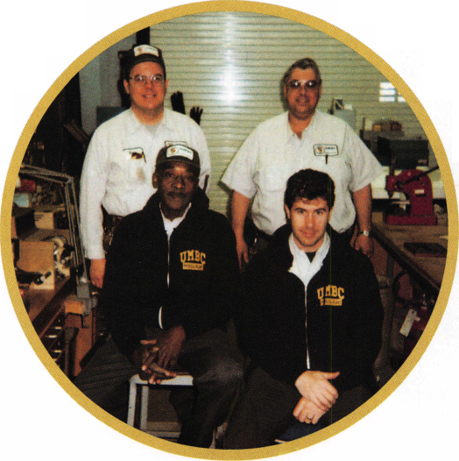

**Nantucket Cottage Hospital Entrance**

**Nantucket Cottage Hospital Nantucket Island, MA**

Institutional locksmithing has come into its own within the last twenty years in America. The old meaning perhaps intended for use in institutions of state and federal agencies has clearly progressed into a number of fields that now apply, medical complexes, school systems, hotels, factories, airports and industrial parks,

to name a few

The maintenance requirements of Insti­tutional Locksmithing is not only labor intensive, but requires a thorough knowledge about a number of complex security systems. Numerous technical support is also required with building tradesmen to coordinate security require­ments within a number of physical buildings within a complex. This complex and demanding skill of being a institutional locksmith is both rewarding to those men and women associated with this field. They are indeed a professional and gifted craftsman, to this field of lock­smithing, and should be accepted by all locksmiths as equals without question. The field of institutional locksmith will continue to gain strength in numbers and will continue to grow in years to come. The locksmiths that are members associated with this particular field of locksmithing belong to a unique organization, The Institutional Locksmith Association.

The Institutional Locksmith Association is a national organization, founded in 1983 to promote the growth and educational development of locksmiths associated in this field. They have sixteen chapters, in several states across the nation. The association

**Mike Ferrill adjusting LCN**

**Door Closure - Main Lobby**

Keynotes

**April** 1999

is made up of men and women of all trades, who by virtue of the fact they “Do” the lock, key, and access control work for their employer “in-house” and are considered by the Institutional Locksmith Association to be the institutional locksmith for that business. The ILA’s toll free number for general infor­mation and membership information is 1- 888-352-5625 . They publish a newsletter called “Key Issues,” and is distributed to its membership. Their mailing address is: Insti­tutional Locksmiths’ Association National Board Office, P.O.Box 1275, Waldorf, Maryland 20604-1275, or they can be contacted at their email address: [inhouse@mindspring.com](mailto:inhouse@mindspring.com).

The current president of the Institutional Locksmith Association is Phillip A. Rovenolt, he is currently employed as the in-house locksmith for the DC Water & Sewer Authority, in Washington, D.C. He is also an instructor at the Prince George’s Community College, 301 Largo Road, Largo, Maryland, where he teaches classes in lock­smithing. He continues to promote current & state of the art educational instruction through the Association’s Annual Convention’s Training Seminar/Class program. This year the Fourth Annual Institutional Locksmith Convention is scheduled for June 15-19, 1999, in Charlotte, North Carolina. The convention site is at the Charlotte Sheraton Airport Plaza, in Charlotte, North Carolina. The Yale Security Group is a major partici­pant for this years conference. A number of excellent institutional locksmithing classes will be conducted at this convention.

The annual membership dues of the ILA is $50, there is a one time registration fee of $20 when first applying for membership. For those of you who haven’t joined yet, please consider this organization for membership. For the cost of one “service charge to that department you’re working in,” you will gain a tremendous amount of practical and technical expertise from the experts of this field through their newsletters and

18

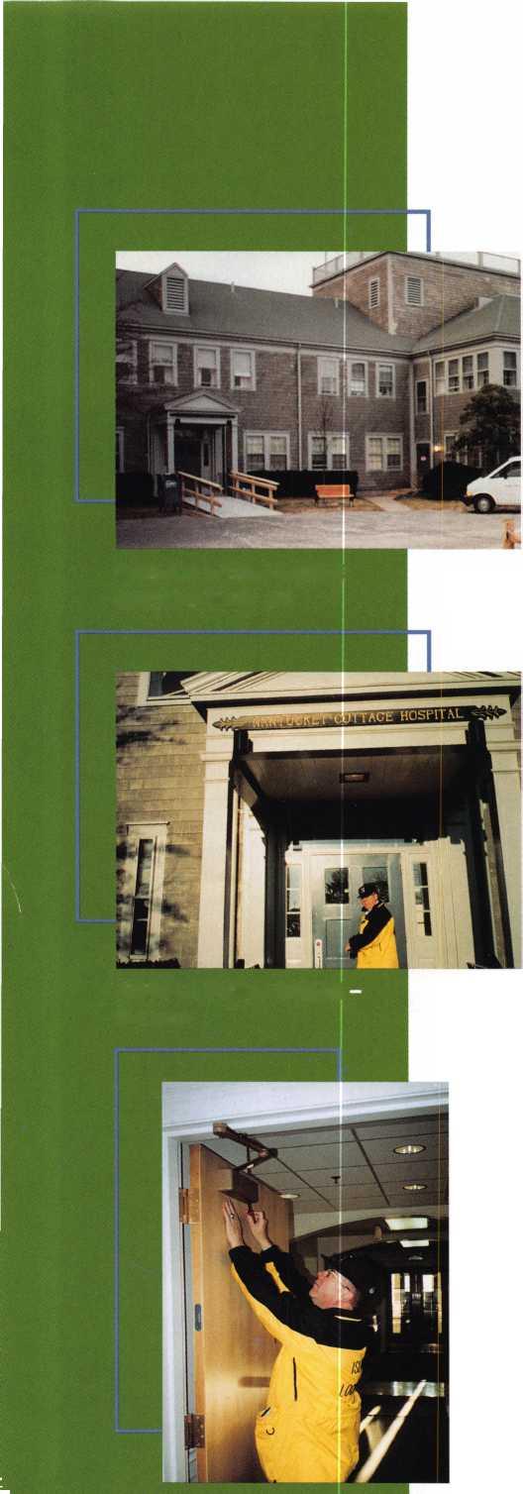

convention seminars and classes. Now lets hospital complexes consist of several on site talk about being a locksmith working in an adjourning buildings. It is two stories high, institutional environment. and houses a complete state of the art

The locksmith that is identified as an medical facility. What is unique about this

institutional locksmith is a unique craftsman small but compact hospital, similar to many in this field. In additional to basic master hospitals on the mainland, is that it must

What is

**tasdiutloiiai**

Locksmithin

**by Michael Ferril**

keying systems that he must organize, maintain, service and implement a number of integrated security systems. He is also responsible for the additional gambit of door hardware associated with various types of doors and windows, through a complex of buildings. He is responsible for mortise door locks, both conventional and electrical, LCN closures, emergency fire and safety exit devices, keyless lock systems, CCTV, high tech monitoring systems, keypad access systems. In addition they are responsible for delayed egress systems, rekeyable padlocks, and high security medical and pharmaceu­tical cabinet locks and doors. The institu­tional locksmith’s responsibilities covers a total area of security features associated with the hundreds of interior and exterior doors within his assigned work area.

On Nantucket Island (30 miles at sea off the coast of southern Massachusetts) the only hospital that we have is called Nantucket Cottage Hospital. Although the word cottage implies a small building, our

provide services to thousands of tourists during the summer months from May to September. This is the time when the population of Nantucket island increases from 10,000 to 40,000.

Mr. Dick Moran is the maintenance engineer responsible for this facility. He has trained his two maintenance personnel Jim Hiltz and Doug Asplint in basic locksmithing. I have been called on several occasions whenever a unique lock problem presents itself, to assist these two experienced professionals. Like their counterparts on the mainland, some of the locks they must repin, repair, and replace within this facility are: the “Best Key System” cam locks, cabinet locks, deadbolts, elevator locks, vending machine locks, escalator locks, doctor and nurse locker locks. In addition they are knowledgeable in several areas of ADA approved, UL Listed lock and door hardware devices. They are required to meet building codes require­ments in both local, state and federal safety requirements. These are some of the

additional skills (to name a  
few), and practicable  
working knowledge that is  
required, in addition to a  
high level of education that  
is needed to be a professional  
in this field:

Mechanical Panic Devices  
¥on Duprin door hardware  
Alarms Fire Detection  
Emergency Exit hardware  
Intercom systems  
High Security locks  
Intrusion Detection systems  
Safes

GSA Containers

Locks for aluminum, wood,  
and metal doors  
High Security lock systems  
Lock systems with  
removable cores  
Secured Containers  
Electrical Panic Devices  
Automatic doors  
Security seals  
Telephone entry systems  
Video entry systems  
CTTV Systems  
Simplex Entrance locks  
Fire and Burglar Alarms  
Fire Proof File Cabinets  
High Security Cabinets  
Strikes and switches  
for electro-magnetic  
systems

Dick provides his staff with a compliment  
of books and reference materials associated  
with the technical aspects of locksmithing .  
In addition their work area consist of  
locksmith parts, hardware supplies, lock sets,  
and specific tools associated with this trade.

Institutional locksmiths are very visible  
within any large institution, be it a hospital,  
university, or a large building complex. They  
are also responsible, because they are the

security experts, to provide to these institu­tions with security protocols for a number of high security entry systems. These include but are not limited to key control systems, card systems, CCTV monitoring systems and perimeter security systems.

There are many benefits associated with institutional locksmithing. In most cases educational assistance (tuition reimburse­ment) to further ones education in this field, health and medical benefits, retirement, annual vacation and those other additional benefits associated with working for any large corporation, or institution.

One of the major benefits associated with being an institutional locksmith is the availability of on-site training programs by major manufactures, that will come to your facility. They will cover product knowledge, installation techniques, repair and parts ordering information. They will also give the institutional locksmith hands on training in all the technical and application processes involved with their product. This is a great physical hands on training program for these locksmiths.

Employment of the institutional locksmith will continue to grow in the years to come. The basic starting salary for an institutional locksmith is at a minimum $13.50 per hour and up to $28 per hour depending upon the type of institution or facility the individual is working in. The salary will be dependent upon geographical location (i.e. New York City, NY vs. Flagstaff, Arizona). The need for this unique type of locksmith will continue to draw quality people to this profession.

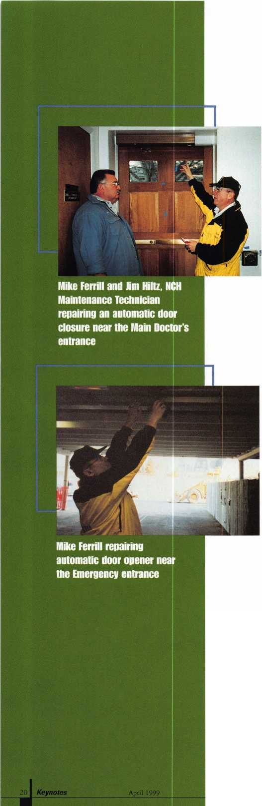

At American Security Distribution, we’ve had our focus on one thing.

Improvement.

Improvement on everything we do - from our CD-ROM catalog to delivery, to support and even education - we’re strengthening our infrastructure to operate at peak performance.

But here’s the most important part:

This focus on improvement is to benefit the real muscle behind our company -

Our customers.

To us it’s simple. We have to be strong to take your operation to the next level. And how we service you is the only way we’ll get there.

American

Security Distribution

we’re Beefing up. For You.

Serving the (J.S. and Canada Corporate Headquarters:

4411 East La Palma Avenue Anaheim, CA 92807

(800) 854-8775 [www.amsecurity.com](http://www.amsecurity.com)

99

IlSEMIRIIWflSIROHaER FUTURE T08EIHHT

27th Annual Educational Conference and Trade Show—*April20-24, 1999*, *Disneyland Hotel  
CALI*, *NOW TO QUALIFY FOR DISCOUNTS ON SEMINA RS AND SHOW SPFCIALS  
Trade Show Hotline:*

**HOW REGISTER ON-LINE**

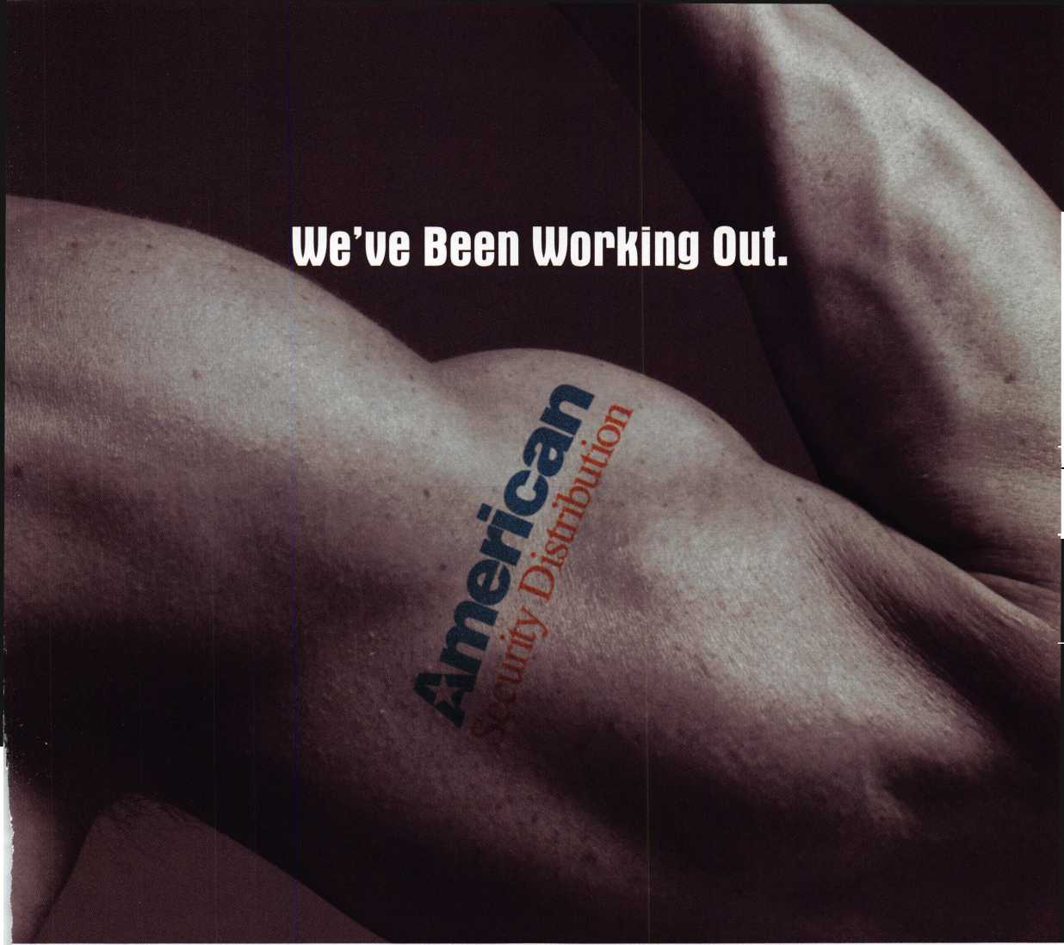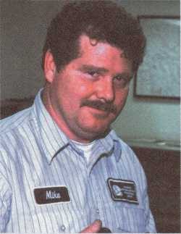

Six years ago, there was an  
opening for an institutional  
locksmith helper at the  
Cincinnati Northern Kentucky  
International Airport. At the  
time, only one man, Michael  
Chambers (currently the airport’s  
building maintenance supervisor)  
handled all the duties of an insti-  
tutional locksmith despite an  
intense demand for these respon-  
sibilities.

The airport’s locksmith shop is  
a part of its general maintenance  
department. Since both depart-  
ments work closely together,  
Chambers would get help from  
someone in the maintenance

department when he was behind from time to time.

“Unlike a traditional locksmith, an institutional locksmith does more than just cut a key and leave the responsibility to the key holder,” says Chambers. “When working at a large international airport there are many security concerns and risks, so the locksmith must be responsible and in control of the keys at all the times.”

He adds that being a locksmith at the airport is very demanding. The daily routine as an institutional locksmith at an airport includes, prioritizing work orders, doing preventive maintenance, handling special key and lock requests, installing and maintaining all types of doors, frames and hardware and working on baggage belts. The person for the position must be self disciplined and have the willing­ness to learn. Fortunately for Chambers that person turned out to be Michael Rummage.

*Michael Rummage,*

*Locksmith/Building Maintenance for the Cincinnati/Northern Kentucky International Airport*

**22** I Keynotes

**April 1999**

“I would help Mike (Chambers) out when he was behind on various tasks and I got interested in doing this,” says Rummage. “I thought, ‘Boy this is great and I really enjoy doing this.’ The differ­ences between an institutional and a commercial locksmith is that, to a large degree, we use a lot of one company’s product. We try to stay uniform because of the high security requirements within the airport. We must keep trained personnel and repair parts on hand so we can get the doors back in service as quickly as possible. We also couldn’t get by without the use of a computer because a lot of our data is stored in them. The computer is used for key tracking and personnel. Key control lets us know where the keys are and who is suppose to have them.”

Rummage, age 43, lives in northern Kentucky near the airport with his wife, Cindy of 23 years and their 17 year old son Chris. Before working at the airport he served six years in the U.S. Air Force and was stationed in Oklahoma.

He started out working in the airport’s general maintenance department 13 years ago. For the last six, he has worked his way from being a locksmith helper to an institutional locksmith. He was interested and very eager to learn because he felt that it was an inter­esting field and most of all, it was a change. He took a correspon­dence course through Foley-Belsaw Institute and after the previous locksmith moved on he was able to move into his position. He started looking for people in the same field to communicate with about the problems he was facing and to get some more training. Then, he heard about ALOA.

He has been a member of ALOA for six years and the Institutional Locksmith Association (ILA) for three years. He serves as the chairman of the local Ohio Valley Locksmith Association. Most of his formal education has been through the classes offered by ALOA. Currently, he’s trying to take as many classes that are offered in the local area and is working towards his CRL certification.

i



“Perhaps the best way to learn a trade is with hands on experience from the ground up, and with as much training and continuing education as possible,” says Rummage. “I believe that continuing education is vital in this trade because the only thing you can guarantee 100 percent is change.” Michael Chambers, the former locksmith and current supervisor of building maintenance added these comments about his proteges progress: “Michael Rummage is very well educated, started from the bottom and worked his way up. He has earned it which is important. He’s very energetic, the go getter type, self disciplined doesn’t have to be told every little step, he just took it and went with it. He wanted to learn and he has done a very good job.”

The locksmith shop at the airport includes three other locksmiths (all three are members of ALOA), Doug DeBuyser, Albert Tenbrink and Jason Smith. One of the maintenance men, Scott Webb, has a background in electronics and he helps the locksmiths with the automatic doors.

Rummage enjoys working at the airport. Aside from enjoying the camaraderie of his support team, he feels that it is a great place to work because of the excellent benefits. “The airport allows us the time and opportunity to take classes,” he says. “They believe the more educated you are, the more valuable you are to yourself and the airport. This allows me the opportunity to advance and further my education all at the same time.”

He also enjoys meeting all the different people from all over the world and the fact that while working at the airport, there are never two days that are always the same.

“Most of all, I enjoy the challenge of knowing what’s wrong and just being able to fix things for people. If you like changes and like meeting people, then go for it. Institutional lock- smithing at an airport might be the thing for you.”

PRISON and JAIL EQUIPMENT

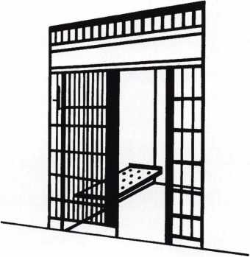

Qeorg,e cA. Keene? 3nc.

1101 NIAGARA FALLS BLVD.  
BUFFALO, N. Y. 14226

**Are You A  
BWD Certified  
VATSmith?**

**Wanna Be?**

HUM!

Locks Kits

Training

Certification

For a FREE VATSmith information packet and  
locations of BWD Certified VATS Centers  
Call

800**-**647-4926

See us at [www.alllock.com](http://www.alllock.com)

**April 1999**

Keynotes

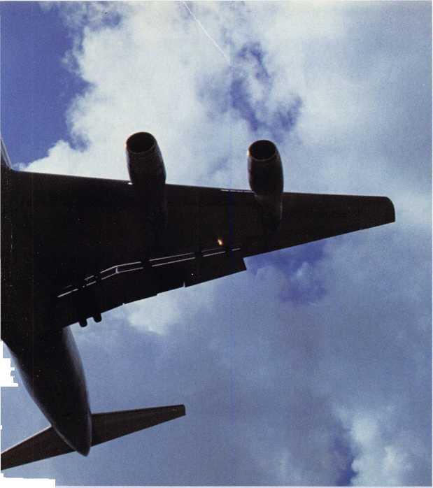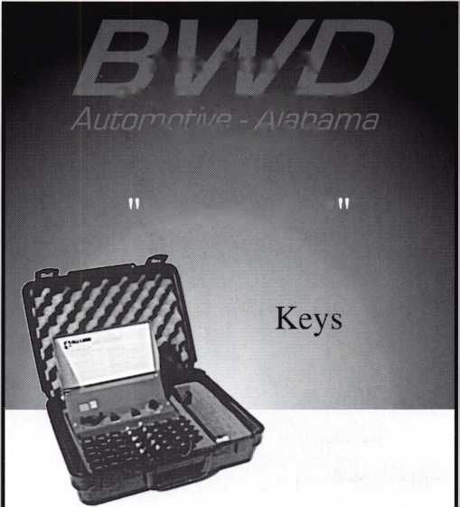

THE SOURCE FOR...

**Hawkeye... Karl Storz**

**two of the finest names in borescopes**

German optics plus quality construction plus a wide range of sizes equals Storz, the leader in industrial visual inspection products.

1 **J See the quality for yourself.**

W~~ Visit Timemaster booth 504 for the OFFICIAL unveiling of this revolution

—j ary line. Video imaging, light sources, other kits and tools available

^SAFETECH '99 *Convention Specials*

Complete **Hawkeye Kit: fiberoptic straight view probe, 90° mirror tube, light handle, carrying case, cleaning kit 7" kit was $590.00** NOW **$520.00**

**12" kit was $690.00** NOW **$608.00 17" kit was $760.00** NOW **$670.00**

ty *

**\* u Time-Master.com (web) • [timstr@AOL.com](mailto:timstr@AOL.com) (email)**

**IME 888 798 8464 / Fax 800 798 TIME (8463) • 785 232 8705 / Fax 785 232 2603  
MASTER . Canada Sales Office: David Bickers 604 944 7129 / Fax 604 944 7248**



**You could roll on out of Cincinnati  
in this “locksmith-ready”**

**1999 Cheurolet Astro Cargo Van  
if you hold the winning ticket  
at AL0A ’99!**

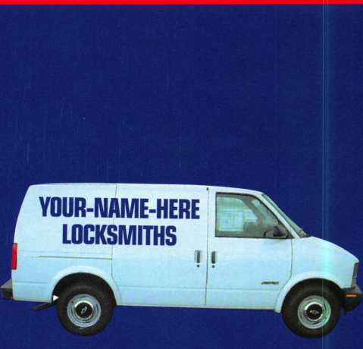

The ALOA Scholarship Foundation will be raffling a 1999 Chevrolet Astro Cargo Van at ALOA ’99 in Cincinnati.

Every adult registrant who attends the convention will be given one raffle ticket. Additional tickets will be sold by the Foundation at the Silent Auction. Exhibitors will also have tickets available at their booths.

The drawing for the van will be held on the show floor during the last hour of the last day of the show. Winner MUST be present.

Keynotes

April 1999

New Security for Storefront Doors

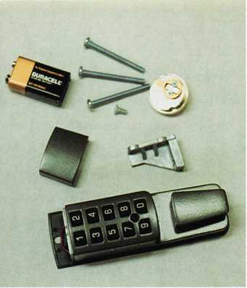

GardLok components-Lock case, battery compartment cover, 9-colt alkaline battery, thru bolts, cam actuator and spacer block.

Walk into almost any convenience store, gas station, dry cleaner, fast food restaurant or other retail establishment and you probably pass through an aluminum and glass “storefront” door. Typically, this door is left unlocked during normal business hours and is secured after hours with a “flip-up” deadbolt, such as the Adams Rite 1850S. The lock is operated by a mortise cylinder and every employee who needs to open or close the store has a key.

Just as most retailers have the same door hardware, most also have similar problems with employee turnover. Many of these employees are minimum wage earners, part-timers or people between careers. Every time an employee with a key is terminated, the lock needs to be changed. This is means more than just the expense of hiring a

locksmith to rekey the cylinder and cut new keys. There is also the logistical problem of getting the new keys to all the necessary people, on all the shifts, so that they can open and close the business.

Some businesses have been willing to spend the money to have a hard-wired access control system installed. A multi-user keypad, magnetic lock, egress control and battery back-up power source would be required.

Mechanical pushbutton locks for storefront doors are cheaper and easier to install. Unfortunately, they only work with springlatch mechanisms which do not provide very good physical security. They also offer only one access code, so when you lock one person out, you lock everybody out.

VTM CARD

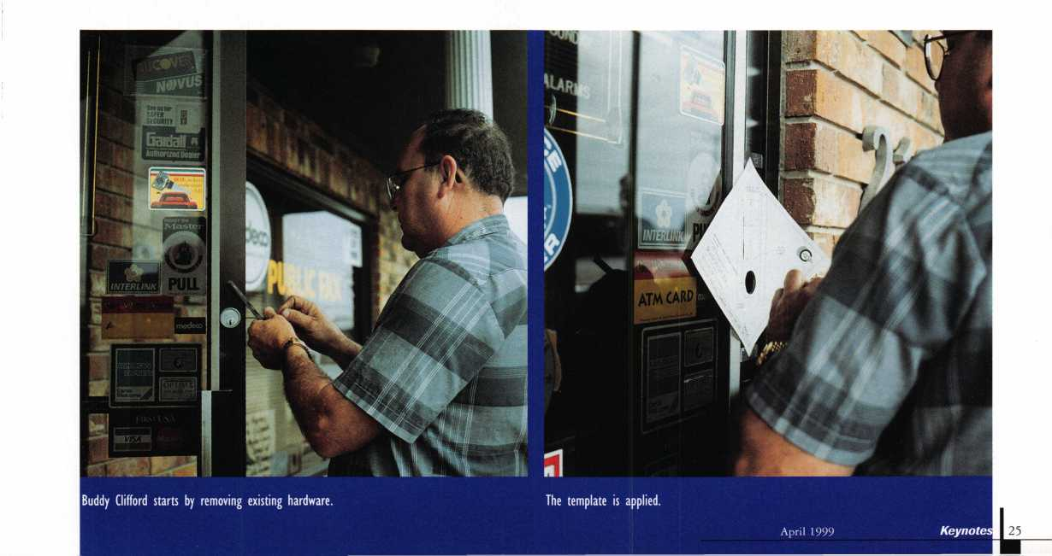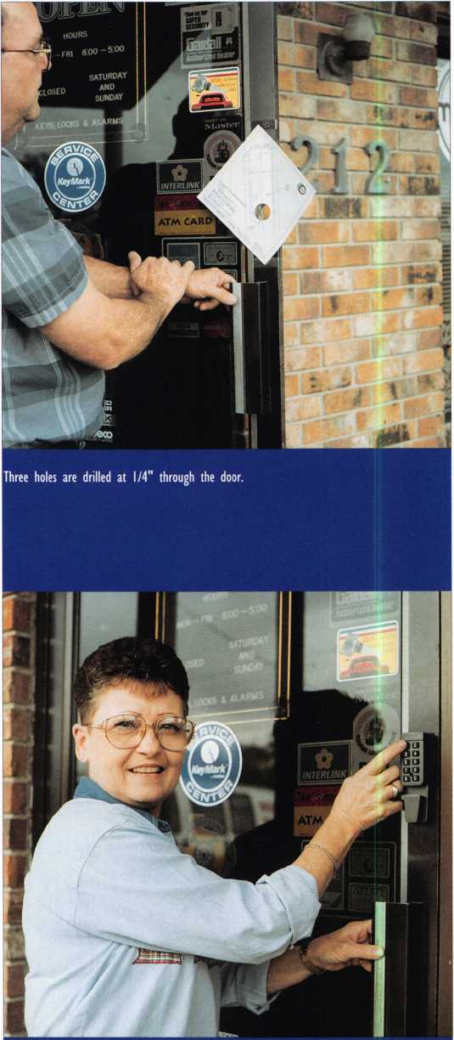

**Judy Clifford tries out the new GardLok.**

Computerized Security Systems (a.k.a. Winfield Architectural  
Lock) has just introduced a new alternative: the GardLok 300.

GardLok is a battery-powered digital code device that works with  
narrow-stile flip-up deadbolt locks. A master code and up to nine user  
codes may be programmed to lock and unlock the door. The master  
code allows you to reprogram any user code right at the keypad. You  
can also disable a user code and then reactivate it quickly and easily.

CSS sent a sample GardLok to Buddy Clifford of Anchor Safe and  
Lock in Lake Jackson, Texas. They asked Buddy to install the test unit  
on his shop, which is located among the chemical plants of the Gulf  
Coast. Hardware takes a beating in the humid and corrosive environ-  
ment in these parts, which should make this a good beta site.

The first step is to remove the existing lock and cylinders. A  
template is provided to help you drill three 1/4 inch holes through  
the door. A spacer block is inserted into the lock cavity and held in  
place with two of the thru bolts. The deadbolt is then reinstalled  
along with the inside cylinder or thumbturn. The Gardlok drive  
assembly is then slipped into the outside mortise cylinder opening  
and fixed in place with the lock’s set screw. Now, the outside case of  
the GardLok is fastened to the face of the door with two thru bolts.

The 9 volt alkaline battery is inserted into the top of the outside case,  
then the battery compartment cover is held in place with the third  
thru bolt.

This installation went pretty quickly. The stile on Buddy’s door  
was pretty narrow and he needed to file a little off the corner of the  
spacer block to make it fit perfectly. Everything else went smoothly.

He estimated that future installations would take about 15 minutes.

Give a new product to a locksmith and his first question is, “How do I break into it?” For example, if the battery goes dead, how do I get the lock open? First, the good news is, GardLok gives you plenty of warning that the battery is getting low. It beeps at you eight times and makes you enter your code twice. People being people, we all know somebody will ignore the signals and let the thing die. If this happens it will be necessary to drill out the top thru bolt, destroying the battery compartment cover.

What if the store owner forgets his master code? There is a process which will allow you to reset the GardLok to the factory default master code of 111111 even when the current master code is unknown.

GardLok gives the retail businessman a nice combination of physical security and convenience. The list price of $ 180 dollars should not be out of the question for the target customers, especially if they compare one GardLok installation to the cost of having their key cylinders rekeyed three or four times.

A KeynotesApril 1999

**SCHLAGE KNOB CYLINDER REMOVAL**

WITHOUT A KEY

BY SAL DULCAMARO, CML

To remove a lock cylinder from a Schlage A series  
(grade 2) commercial knob lock, you normally

need the operating key. You would insert the  
correct key, turn the key (which causes the  
plug to rotate, along with the attached flat  
tail piece) and push on a spring loaded knob  
retainer which is accessible through a poke  
hole in the neck of the outer knob. The outer  
knob could then be pulled off, and the

cylinder removed for servicing.

If you lacked an operating key,  
you would need to find another way  
to rotate the plug (and move the  
tail piece out of the path of the  
retainer) such as picking the lock or

impressioning a new key. If you had the  
misfortune of coming across a Schlage cylinder  
coded with all six pin chambers filled with alter-  
nately long and short bottom pins, picking or

impressioning might be a greater challenge than usual.  
You might ultimately consider the possibility of drilling  
for the shear line of the lock cylinder.

Schlage knob cylinders aren’t cheap. Never mind the cost of a new cylinder. You might be in a situation where you don’t have a replacement cylinder to take the place of the drilled out one. Fear not. You have another non­destructive option to picking or impressioning. There is another way for you to safely move the tail piece out of

the path of the knob retainer, but some additional lock  
disassembly will be required.

Photo 1 shows a Schlage A53PD knob  
lock removed from a door. If you look closely,  
you will see the knob retainer access hole at  
about nine o’clock in the neck of the outer knob.  
If you had a working key, you could have left the  
lock on the door and removed just the knob itself.  
Being that the operating key is missing, the

lock must be both removed from the  
door and then disassembled to gain  
access to the cylinder.

With the lock already removed,  
the first step in disassembly is shown  
in photo 2. There are two cotter

pins that must be removed before the  
housing will come off. With the cotter pins taken  
out in photo 3, the housing can be worked  
loose and pulled off. After the housing is removed  
in photo 4, additional moving parts of the chassis

are now exposed. The spindle and plunger assembly is held  
in place by the hub plate. Tabs on either side must be

slightly spread outward to release the hub

plate. In photo 5,1 am using my  
thumbs to disengage the tabs from the hub  
plate. Depending on your hand strength,  
you may need to use a flat screwdriver or other

tool to help pry it apart.

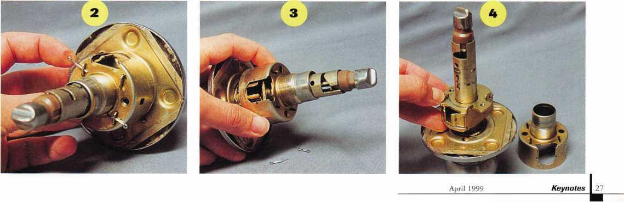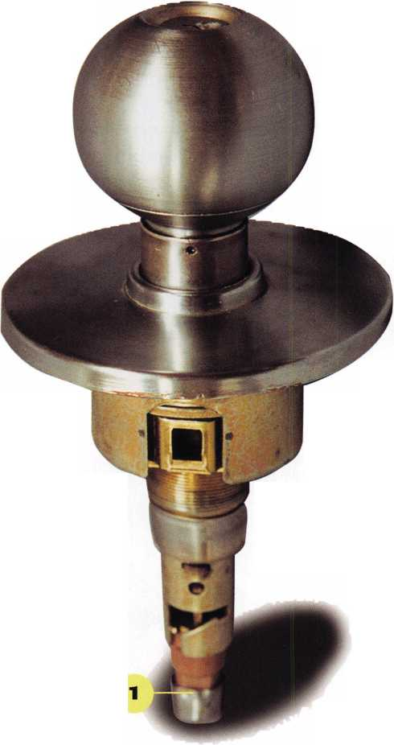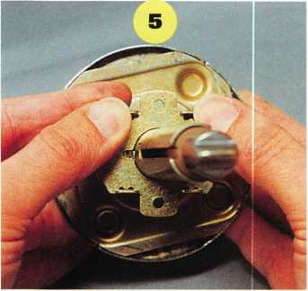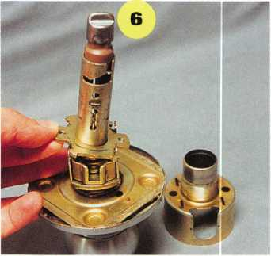

One side of the hub plate is disengaged in photo 6, but the plunger is still engaged

with the slide assembly (or latch retractor). I am pushing in the slide, in photo 7, which allows me to disengage the bottom end of the plunger. The spindle, plunger and hub plate have been removed together as a unit in photo 8. Moving the slide inward takes some effort because of the strength of the two fairly large slide springs. You may have to push it in as far as it will go, in order to disengage the end of the plunger. To remove the slide, you should push it in slightly against the spring pressure, and then tip up the front end of the slide, as in photo 9- Relieve the spring pressure gradually, so they don’t become unhooked and shoot across the room. The springs are large, so if they do fly off, they shouldn’t be extremely difficult to see. Photo 10 shows how the end of the plunger hooks under and is engaged by the slide.

With the slide and springs removed, you can see the end of the outside spindle in photo 11. Notice the half moon shaped end (toward the bottom) which normally engages the slide and acts to retract the latch when the outer knob is rotated. Rotating the knob one half turn, in photo 12, moves the half moon shape to the top. A matching cutout pattern/shape in the outside hub plate will allow the knob (attached to the outside spindle assembly) to pull outward, as in photo 13. You will probably have to do a combination of rotation and pulling to completely take out the outside knob and spindle. Photo 14 shows it after it has been removed. I am pointing to a narrow slot in the neck of the knob where the knob retainer is visible. Next, the cam unit is being removed in photo 15.

The cam unit has been removed in photo 16. The slot in the end of the cam unit is

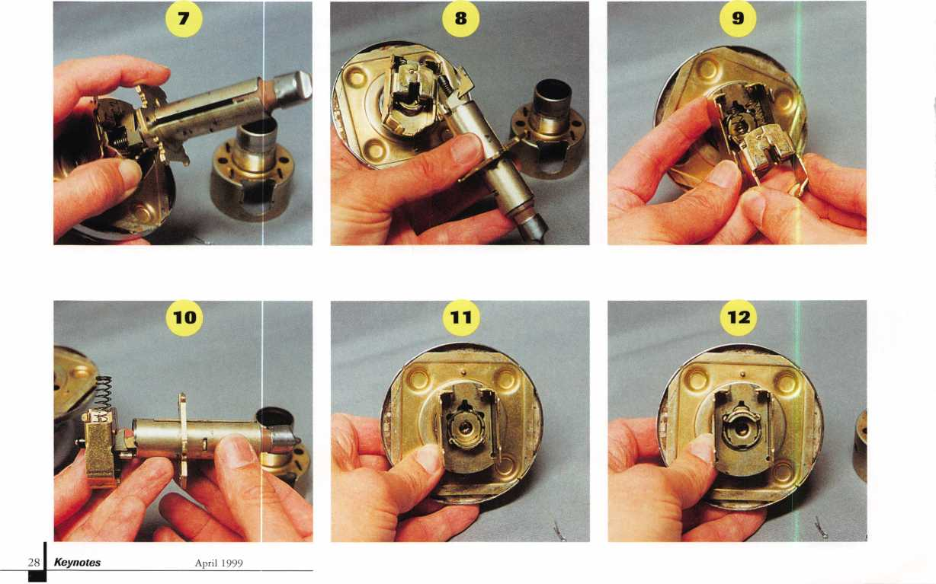

where it engages the flat tail piece at the back of the Schlage knob cylinder. If you look inside the end of the knob and spindle, you can see the flat tail piece as a vertical line. Just below it is the somewhat “E” shaped knob retainer. The middle line of the “E” is in line with the tail piece. If you tried to push the retainer inward, the tail piece of the cylinder would block the motion. If you rotated the plug (with an original or impressioned key, or by picking) the tail piece would move out of the path of the retainer.

We have presumed, up to this point, that the lock is not picking or impressioning easily, and that we don’t already have an operating key. That means we are unable to rotate the plug. I will now demonstrate how we can rotate the tail piece without having to rotate the plug.

I have positioned a Schlage knob cylinder, in photo 17, in the same relative position as the cylinder currently inside the knob previously shown. This gives a clearer view of what we are going to do. You will need an ice pick or scratch awl (or similar tool). I’m using the sharp end of the awl to point to the retainer pin that holds the threaded end cap (of a Schlage knob lock cylinder) from loosening or tightening on its own. With the cylinder out of the lock, it is a simple task to just push the spring loaded pin inward and unscrew the cap. With the cylinder inside the knob, our access and motion are more severely limited.

In photo 18,1 am using the tip of the awl to both depress the retainer pin, and slightly rotate the end cap. Photo 19 shows the awkward position of the same operation with the cylinder inside the knob. I am able to rotate the cap only a few notches at a time. It may take me up to 10 similar motions to fully rotate the end cap one time. I don’t need to completely unscrew the end cap to separate the motion of the tail piece from the motion of the plug. In fact, there isn’t enough space to rotate the cap more than a few rotations anyway. Photo 20

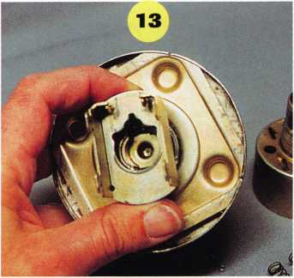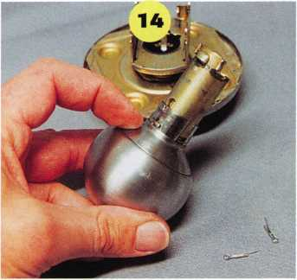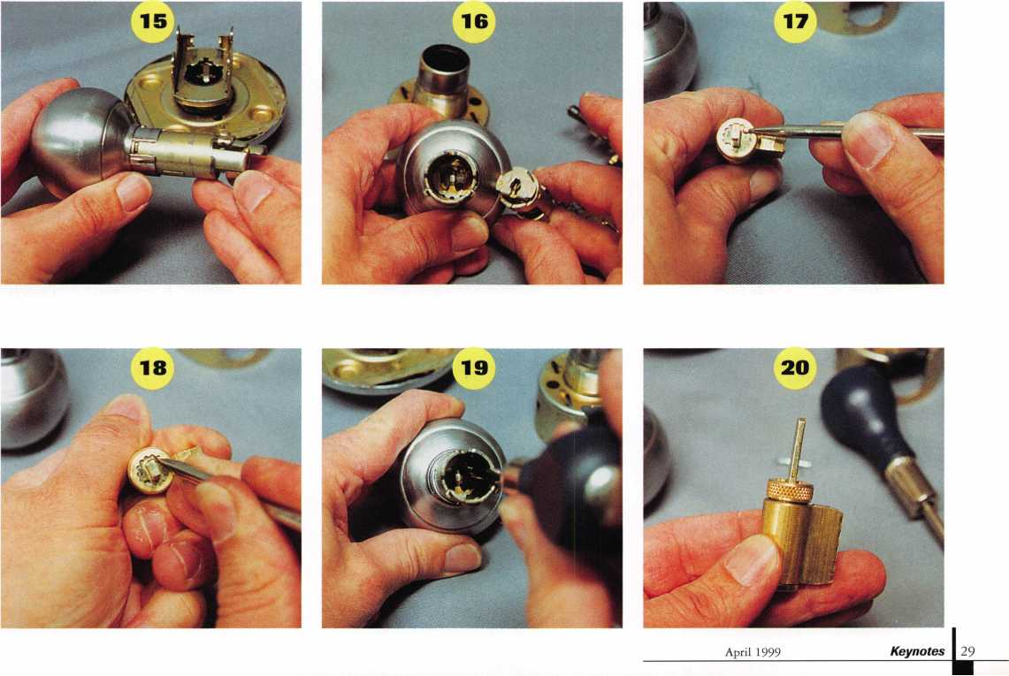

STRATTEC TECH



WHEN SERVICING CM VEHICLES WITH VATS/PASSKEY LOCKING SYSTEMS, HOW CAN I ELIMINATE CALLBACKS AND ENSURE THAT MY CUSTOMERS GET YEARS OF RELIABLE SERVICE?



BY USING STRATTEC REPLACEMENT PARTS AND KEYS. THESE OEM PARTS MEET ALL DESIGN AND SPECIFICATION STANDARDS BECAUSE THEY'RE THE REAL ORIGINALS.

#598512- #594201 - #598525

#594215

#596772-

#596785

Since 1986, General Motors has  
been using the VATS/PASSKey lock  
system. It was first used on the  
Corvette, where it produced a 45  
percent theft reduction. Soon after,  
GM incorporated this technology  
into its Chevrolet, Pontiac and Cadil-  
lac vehicles, until now there  
are thousands of VATS/PASSKey-  
equipped vehicles on the road.

When your customers need service,  
they expect the best. STRATTEC  
key blanks and replacement parts  
provide real OEM performance  
and reliability because they're the  
same parts that GM chose for its  
most prestigious nameplates.

**STRATTEC**

**For** more information, please  
call your STRATTEC authorized  
wholesale lock distributor



shows a very slight separation between the end cap and the back surface of the shell of the knob lock cylinder. The cap has been rotated counterclockwise about three full turns. The cap only needs to be rotated enough to allow the retainer pin to be fully compressed below the tail piece, so the tail piece can be rotated over the top of the pin.

When there is enough room for the retainer pin to compress below the surface of the tail piece, you will need to use the awl to push the pin below the surface and another tool to rotate the tail piece at the same time. Photo 21 shows a tool I made out of a square metal stock, for that task. The notched end of the tool will fit over the flat tail piece, and act as a wrench to rotate it. A pair of long nosed pliers or anything else narrow enough to fit down the opening of the spindle will accomplish the same goal.

In photo 22,1 am using the awl to push the pin inward. At the same time, I am using the other tool to try and rotate the tail piece counterclockwise. When I am able to get the tail piece to start to move, I can stop pushing with the awl. That is because the retainer pin will become trapped beneath the tail piece and will not be able to push upward to relock the end cap. I continue using the tool, in photo 23, to rotate the tail piece further. I will generally try to rotate it about a quarter turn.

The tail piece is in an identical position within the confines of the knob, in photo 24. The tail piece is now out of the path of the knob retainer. I can now activate the retainer through the access/poke hole, and remove the knob. Once the knob is detached from the spindle, the knob lock cylinder can be taken out of the knob. It can then be easily serviced, and the lock reassembled. Even if the lock cylinder was difficult to pick, it should be fairly easy to shim open after the cylinder is out of the knob. It may seem like a long and tedious process, but it can be routinely accomplished from about five to 10 minutes, with a little bit of practice.

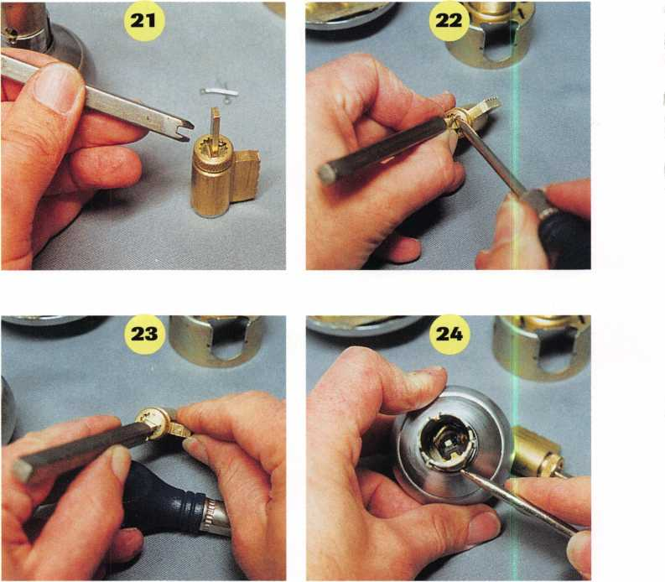

April 1999

30 | ***Keynotes***

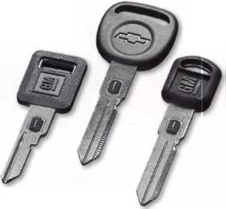

Saf(Dufcatnaro, *CUIj*

Last year, I wrote an article about a company called Security Technology Interna­tional, Inc. (STI). They make and sell special tamper resistant covers for fire alarm pull stations and other safety and security device related guards and covers. They also sell exit alarms and other security devices designed for the institutional or commercial customer. Over the years, they also sold a few consumer oriented electronic security devices. Over time, many of the consumer items gave way to more commercial oriented products. Bowing to customer demands, they have moved more dramatically in the direction of consumer oriented security devices. Instead of marketing them at STI, they decided to create a separate company to serve that market. The new company is called Americorp International, Inc. Their first flyer/catalog displays an interesting variety of gizmos and gadgets, most for personal or home security. I’ll demonstrate a sampling of their product line.

Photo 1 shows the Mugger Stopper Plus.

It is a personal alarm. It can be carried in a purse or pocket, and when it is triggered it emits an ear piercing 120 dB alarm and flashes an attention getting strobe light. In photo 2, I’m pointing to the pin that, when

pulled, trips the alarm. To the right of the device are a number of cords and clips that can be hooked onto the pin to allow easy triggering in a panic situation. It can also be rigged to protect an item or carrying case with valuables inside. Putting the device inside a purse and wrapping the cord around ones wrist would cause an alarm to sound in a purse snatching incident. The noise and light would call attention to the perpetrator and might cause him/her to drop it and go on his/her way. Photo 3 shows how the part that is the strobe light can also work separately as a flashlight. The device is compact, light weight and shock resistant.

Americorp also sells a more basic model Mugger Stopper, which is nearly the same but lacks the strobe/flashlight. They both use a 9 volt alkaline battery (not included). The basic model sells for $3.62 wholesale, with a suggested retail price of $6.95. The Mugger Stopper Plus is $3-95 wholesale, and $7.95 suggested retail.

A variety of Sensor Night Lights are shown in photo 4. They are available in either black or white. The small lights are $2.19 wholesale and $4.97 suggested retail. The larger lights are $3.70 wholesale and $7.97 suggested retail. They have an

**April 1999**

Keynotes ±ii

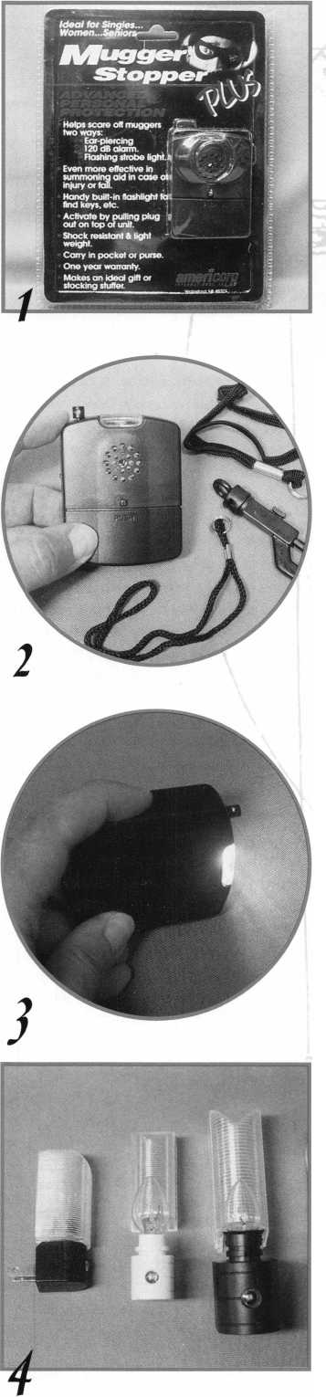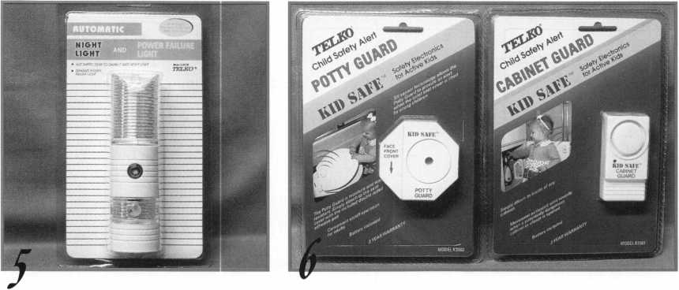

interesting variation to the standard night light in photo 5. It is a Power Failure Night Light. Most of the time it works like a standard sensor night light, but if the power goes out the other light comes on. This two- in-one night light has a battery back-up. It has an AC sensor light that goes on and off automatically depending on the darkness of the room. The other part is a DC battery sensor night light. It converts back to standard operation as soon as power is restored. Both units use standard seven watt night light bulbs. The built in rechargeable battery will operate for up to two hours during a power outage. The wholesale price is $8.70, with a suggested retail price of $19.99.

Americorp also carries a number of child safety devices. Photo 6 shows a Potty Guard at the left and a Cabinet Guard at the right. The Potty Guard attaches to a toilet seat. A built in tilt switch causes it to sound when the lid is lifted. An on/off switch lets adults turn it off during toilet use. If a small child lifts the seat, an ear piercing noise will alert adults, and help avoid an accidental drowning of a young child. The wholesale price is $5.65 and suggested retail is $12.95.

The Cabinet Guard has a light sensor that triggers an alarm when a cabinet door opens and is exposed to light. It is ideal for cabinets off limits to the children, the wholesale price is $5.65 , and $12.99 is the suggested retail price.

Photo 7 shows two different door alarms. At the left is a Child Safety Alert Door Monitor, and to the right is an STI Doorknob Stopper. The octagon-shaped alarm unit attaches to a door. A magnetic switch triggers the alarm when the door is opened. If a child wanders out the door, this should alert an adult in the house in time to avert an accident. A switch on the side of the unit, visible in photo 8, has an off setting with the choice of alarm or door chime. It has a reset/delay button for silent adult operation. Wholesale price is $8.70, and suggested retail is $19-99.

The Doorknob Stopper, in photo 9, is a portable door alarm. It is well suited for travelers who want to increase the security of their hotel rooms. It hangs right over the top of a knob or lever handle. When switched on, a vibration sensor will detect the door opening or possible tampering with the door. The switch also has a chime setting in

contrast to the alarm setting. It can also be used as a personal protection device by switching it off and pulling the chain (which pulls a pin at the top) and setting off the alarm. The wholesale price is $7.12, and $19-95 is the suggested retail price.

Photo 10 shows the Audio Alert Patient Protector. It is designed to alert someone to the fact that a patient has wandered off.

Photo 11 shows the main unit. Next to the main unit is a magnetic sensor with a length of string and clip attached. The main unit can be attached to a bed or chair. The magnetic sensor can be attached to the metal strip in the unit and the clip end can be attached to the patient’s sleeve or other article of clothing as shown. If the patient wanders further than the length of the string, the magnetic contact will be pulled off and the alarm will sound. The wholesale price for the Audio Alert Patient Protector is $9.07, and the suggested retail price is $24.95.

A somewhat unusual security device is shown in photo 12. It is called “Rex.” It is a barking dog alarm. Inside the black plastic box is a movement sensor. When someone travels within a range, the alarm goes off.

The sound of the alarm, though, is the sound

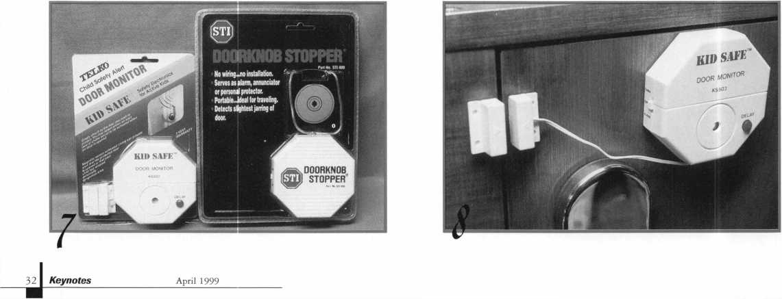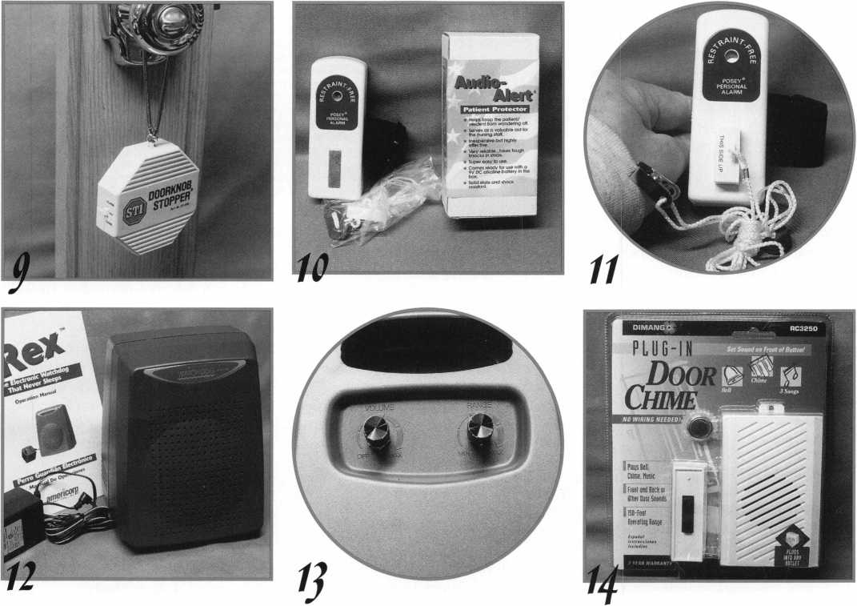

of a barking dog. Let me tell you that it sounds like a fairly large dog at that. Photo 13 shows the back of the unit with the controls. The volume switch allows you to control how loud the barking sound will be. The range control allows you to decide how close someone can approach the unit before triggering the alarm. The closer the intmder comes to the unit, the louder and more frequent the barking becomes. As the intruder goes away, the noise of the barking dog reduces in frequency and intensity. Your very own maintenance free watch dog. Rex has a wholesale price of $44.95 and a suggested retail price of $89-95.

Photo 14 shows a Plug-In Door Chime. As a normal door bell, it is ideal if you don’t want to go through the trouble of drilling through walls and running wires. You can also, I suppose, use it as a call button or alarm for an invalid or temporarily disabled family member. The button could be placed within reach of the person’s bed, and the chime could be plugged in wherever the care giver is situated throughout the house. It has a choice of different sounds. The wholesale price is $24.47, and the suggested retail is $39-99- There are many other interesting items in their catalog. If you would like to order items or just need additional information, call Americorp at: 888/883-3078. The hones are answered Monday through Friday, from 8 A.M. to 5 P.M., eastern time. Orders are taken 24 hours a day at their website: [www.americorp-usa.com](http://www.americorp-usa.com)

INTERCHANGEABLE CORE PRODUCTS

Interchangeable

with:

•BEST • ARROW •FALCON /

Quality **•** Price *Delivery*

That's what KSP is all about!

KILLEEN SECURITY  
PRODUCTS

Ask your wholesaler about  
our drop shipping**.**

**CONTROL**

***33 Hermon St.  
Worcestert IRA 01610  
Phone (508) 798-3200  
Fax (508) 753-2183***

**April 1999**

Keynotes

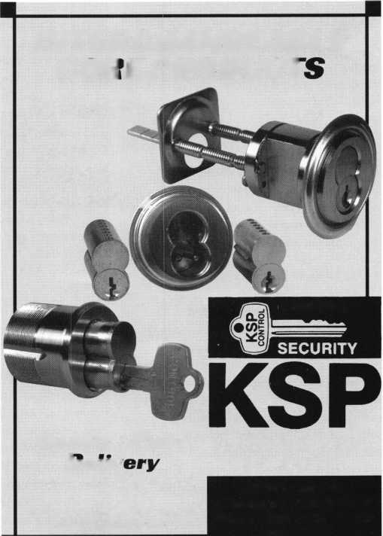

A

Keynotes

Classified



Dept

**Classified Advertising Policy**

**Classified advertising space is provided free of charge to ALOA members, and for a fee of $.60 per word, $15 minimum for non-members. Classified ads may be used to advertise used merchandise and overstocked items for sale, “wanted to buy” items, business opportunities, employment opportunities/positions wanted and the like. Members or non-members wishing to advertise services or new merchandise for sale may purchase a “Commercial Classified Ad,” for a fee of $1.30 per word, with a minimum of $40. Each ad will run for two issues. For blind boxes there is a $5 charge to members and non-members. All ads must be submitted in writing to the ALOA office by the fifteenth of the month, two months prior to issue date. Send to Keynotes Classifieds, 3003 Live Oak St, Dallas TX 75204-6186. ALOA reserves the right to refuse any classified advertisement that it deems inappropriate according to the stated purpose of the classified advertising section.**

■ EMPLOYMENT

Locksmiths and Apprentices Wanted

3/F/3: Locks & Keys of Woburn, Mass, seeks self-motivated, reliable individual to perform automotive, commercial and residential locksmith work. We offer a flexible schedule and will train qualified applicants. We are not a family business and you will be compensated for your experience and hard work. All inquiries strictly confidential.

Send resume to: hocks & Keys, Inc.

P0 Box 222 Woburn, MA 01801

Safety Technicians Needed

3/F/3: Get lucky and work in booming Las Vegas. Great work environment. Great weather, great income potential for experienced, motivated, hardworking technicians and team players. Paid holidays, vacation, medical, 401K plan and in-house training. Don’t delay. Fax your resume today. Fax resume to:

Liberty Lock and Safe (702) 876-5470 or send to:

5470 W. Sahara Ave.

Las Vegas, NV 89146 website: [www.libertylock.com](http://www.libertylock.com)

Experienced Locksmith Wanted

3/F/3: Well established Houston company seeking an experienced Locksmith with tools and a vehicle. Excellent pay, commissions, paid vacations and bonuses.

Call: (281) 497-5555 or (715) 266-4350

Commercial Locksmith Wanted

3/F/3: Experienced commercial Locksmith wanted for the Southern California area. Large commercial based locksmith and door company is seeking experienced locksmiths with a minimum of two years of field experience. Safe experience helpful and vehicle and tools provided. Benefits include excellent pay, profit sharing, medical and dental, paid holidays and vacation. This will be the last job of your career. Immediate openings. Only qualified candidates.

Fax resume to: (800) 804-0063 or call: Bob Madsen at (562) 862-1782

^ **April 1999**

Locksmith Wanted

3/F/2: Work for a 24 year-old company in the Great Northwest. Excellent salary with a 401K, paid holidays, health insurance and immediate vacation accruement. Door hardware knowledge required. Storefront and hollow metal door experience a plus. No auto experience required. Lucrative after hours work optional. Must have good communi­cation skills, professional attitude and a clean driving record.

Send resume to:

The Lock Shop 31008 Pacific Hwy S.

Federal Way, WA 98003 (253) 839-3443

or fax to: (206) 946-6143

Locksmith Wanted

3/F/3: Broward Century Locksmiths Inc. is seeking motivated technicians! Positions available for inside and outside technicians. We are a progressive full service locksmith and electronic security company specializing in commercial, residential, safes and access control (no automotive). We are located in southeast Florida with two locations and excellent working conditions. We provide paid health insurance, vacations and holidays. Experience with access control and safes a plus, but not necessary. If interested in joining our team, sent resume to:

Broward Century Locksmiths, Inc.

Attn.: Mike Sullivan 3 7 Northeast 2nd Avenue Deerfield Beach, FL 33441 (954) 427-7008 Fax: (954)427-7050 Mike@browardcentury. com

Locksmith Wanted

2/F/3: Southwest Detroit establishment of 55 years seeking employees for inside and outside help. Inside help must have one year experience. Outside help must have one year experience and good driving record. We only work with commercial accounts. Uniforms will be provided, BCBS, hourly wages. Can move up to salary. Sick days and vacation days are paid for. Outside help will have full service van. Please, serious people only apply. Fax resume to:

(313) 894-7586

Manager Wanted

3/F/3: Six person shop needs a Locksmith with excellent understanding of the industry and desire to help manage the shop. Located in beautiful downtown Portland, the shop specializes in high security hardware. Low-voltage experience and computer skills a plus. Candidate must be responsible and enjoy working with people. Must have personal tools and some after hours work required. Salary range is from 28 to 34K. Benefits also include a retirement plan.

Send resume to:

Neal McMahon McMahon’s Locksmiths 401 W. Burnside St.

Portland, OR 97209-3817

Locksmith Wanted

2/F/3: Land of Milk and Honey. Minneapolis-based lock company looking for experienced technician (minimum five years please) for service call work. Professional appearance and attitude required. Must have own vehicle and basic lock tools. Safe experience a plus.

All inquiries to:

Gatekeeper Locksmithing Co.

(612) 926-7741

Locksmith Wanted

2/F/3: Fast growing company in Woburn, Massachusetts seeks experienced locksmiths and apprentices to join our team. We perform 24-hour service for automotive, commercial and residential work and offer flexible scheduled shifts to meet your needs. Salary commensurate and all inquiries kept confidential.

Call John:

(781) 933-9999

or send resume to:

Locks and Keys, Inc.

P0 Box 222 Woburn, MA 01801

■ SITUATION WANTED Locksmith for Hire

3/F/3: Bonded locksmith, deadbolts, alarms, locks installed, cylinders, rekeyed, house locks keyed alike.

Call: Joseph Musac (516) 822-5903

ALOA HAS  
FAX ON  
DEMAND!

■ BUSINESSES FOR SALE Portable Locksmith Shop

3/F/3: Keys, key machines, locks and supplies $32,000 delivered. Includes 30,000 keys, dimple machine, 1200 dialer, lever lock, safe rig, code books, Kwikset, auto, pin kits, high security machine, locks, clippers, IC punch, 10 key machines. Includes help starting your own mail order/internet business video.

Call Randy. (800) 332-1773.

Complete Mobile Shop

3/F/3: Buy today and start making money tomorrow. 1996 Ford E250 white van, 30,000 miles. Includes AM/FM cassette, cruise control, A/C, Medeco ignition, steel bulk head, insulation, paneling on the walls, and an amber emergency light on top. Mobile phone, two way radio, 110 Vac lighting with a Honeywell 1600 watt generator, HPC 1200 CM and 025 duplicator, 003 Lab pin kit, Formica counter top workbench, Weather Guard metal cabinets, Craftsman Bench vise, manual credit card imprinter, All-Lock a 7000 Vats decoder, A1 GM 10 cutting tool kit, 1/4" steel letter and number stamps. Snap-On Magnetic tool strips. Complete set of ProLok car opening tolls and books. $45,000. Must sell! Serious inquiries only.

Call: (913) 330-3397.

**m** WANTED TO BUY/SELL Items For Sale

3/F/3: A-l PAK3, Auto key punch with case and A-l PAKCL Chrysler,

A-l PAKG1, GM Multi-Purpose,

A-l PAKF1 Ford 10-cut. Paid $586.00 or best offer.

Respond to:

2820 LaPlant Rd.

Grand Rapids, Minn. 33744

Invention for Sale

3/F/3: Heavy Duty sliding-door lock, patented in the U.S. and Canada. Can be fitted with single or double cylinders for key operation on both or either side. Can be keyed to most cylinders in the market. Prototype available.

Call: (230) 763-7388 (230) 763-7332 fax

Code Machine For Sale

3/F/3: ITL 950 code machine, nearly new (3/98) in box with all manuals and instructions. Very light use. Use either 12 or 120 volts. $1,550. Currently relocating business.

Leave message for Mike:

(978)276-1811

Best Items Wanted

3/F/3: Searching for any old or current original Best items - logo, padlocks, keyblanks, cores, key machines, etc.

Contact:

Richie Sommers I Above All Locksmiths

(718) 671-3227

Van For Sale

3/F/3: 91 Aeromate walk-in Van, custom and Adrian steel cabinets, custom lighting, upgraded alarm system, HPC 1200 Code Machine, HPC 4444 Copier (copied less than 1000), Redi-Line converter, only 39,000 miles. Just move in your tools and go to work! $13,500.

Call: (949) 438-7439

Safe Manual

3/F/3: Fichet-Bauche Safe Manual wanted urgently by Irish ALOA member.

Call Basil Shannon:

(333) 348-3328 or fax: (333) 348-3301

G. Keene

GPLA

Intralock  
KSP __

Locksmith Ledger  
Marray

SAFETECH ’99

Strattec

Timemasters

_IBC

7

IFC

_30

_24

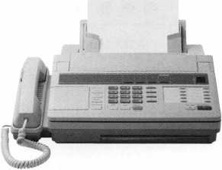

NEED INFORMATION  
IN A HORRY?

Just call 310.575.5074  
and you will be faxed:

#1 A list of all documents available through this service #2 Becoming A Locksmith #3 Locksmith Career Summary #4 Locksmith School List #5 ACE Class Schedule #6 Certification Information #7 PRP Category List #8 ALOA Membership Application #9 ALOA List of Benefits #10 Scholarship Application Form #11 ALOA Video Library Order Form #12 ALOA Membership Items Order Form #13 Safe & Vault Technicians Association Member Application/Subscription Form #14 ALOA Chapter Roster #15 Legislative Action Network #16 Legislative Action Network Newsletters #17 Various State Laws #18 Industry Position Paper

YOUR ASSOCIATION  
CONTINUES TO EXPLORE  
WAYS TO PROVIDE YOU,  
OUR MEMBERS,  
WITH NEW BENEFITS  
AND SERVICES.

**April 1999**

Keynotes -

L

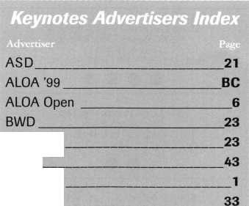

Associate

Members



|  |  |
| --- | --- |
| Manufacturers | Arrow Lock Company  10300 Foster Avenue  Brooklyn, NY 11236 (718) 257-4700; FAX (718) 649-9097 |
|  | a a a a |
| A & B Safe Corp.  171 S. Delsea Dr.  Glassboro, NJ 08028 (800) 253-1267; FAX (609) 863-1208 | Auto Security Products (A. S. P.)  P.0. Box 10  Redmond, WA 98073-0010 (425) 556-1900; FAX (425) 558-1205 |
| • • • • | a a |
| ASSA Inc.  10300 Foster Ave.  Brooklyn, NY 11236 (800) 235-7482; FAX (718) 257-2772 | BWD Automotive  900 Ravenwood Dr.  Selma, AL 36701  (334) 874-9001; FAX (334) 874-6011 |
| • | a a |
| Abus Lock Company  3555 Holly Lane North  Plymouth, MN 55447-0507 (800) 352-2287; FAX (612) 509-9939 | Chicago Lock Company  10100 88th Ave.  Pleasant Prairie, Wl 53158-0069 (800) 445-3204; FAX (414) 947-7178 |
| • | a |
| Adams Rite Manufacturing Co.  P.0. Box 1301  LaPuente.CA 91749-1301 (562) 699-0511; FAX (562) 699-5094 | Corbin Russwin Architectural Hardware  P.0. Box 25288  Charlotte, NC 28229 (800) 543-3658; FAX (800) 447-6714 |
| ease | a a a a |
| Adesco Safe Manufacturing Co.  web: [www.adesco.com](http://www.adesco.com) email: [sales@adesco.com](mailto:sales@adesco.com) (800) 821-6803; FAX (562) 408-6427 | Curtis Industries  6140 Parkland Blvd, Ste. 300  Mayfield Heights, OH 44124-4103 (800) 555-5397 |
| • | a a |
| Adrian Steel Company  web: [www.adriansteel.com](http://www.adriansteel.com)  Adrian, Ml 49221  (800) 677-2726; FAX (517) 265-5834 | DETEX  302 Detex Dr.  New Braunfels, IX 78130 (800) 729-3839; FAX (830) 620-6711 |
| • | ^ ^ |
| Alarm Lock Systems, Inc.  345 Bayview Ave.  Amityville, NY 11701 (800) ALA-LOCK; (516) 789-3383 | Don-Jo Manufacturing, Inc.  P.0. Box 929  Sterling, MA 01564 (508)422-3377; FAX (508) 422-3467 |
| • | a a |
| Aiphone Intercom Systems  1700-130th Avenue, NE  Bellevue, WA 98005 (425) 455-0510; FAX (425) 455-0071 | Door Controls International  2362 Bishop Circle East  Dexter, Ml 48130  (800)742-3634; FAX (800) 742-0410 |
| ^ @ (0 | a a a a |
| American Lock Co.  3400 West Exchange Road  Crete, IL 60417-2099 (708) 534-2000; FAX (708) 534-0531 | ESP Lock Products, Inc.  375 Harvard Street  Leominster, MA 01453 (978)537-6121; FAX (978) 534-9109 |
| a a | a a |
| American Security Products (AMSEC)  11925 Pacific Ave.  Fontana, CA 92337-6963 (800) 423-1881; FAX (909)685-9685 | Folger Adam Security, Inc.  16300 W. 103rd Street  Lemont, IL 60439  (630) 739-3900; FAX (630) 739-6138 |
| a a | a a |
|  |  |

Associate members of the Associated Locksmiths of America (ALOA) manufacture or distribute materials or equipment, or provide services, for the security industry. Many have donated money, services and equipment to ALOA in addition to their annual dues. Their support of ALOA projects enhances overall membership benefits and we encourage our members to patronize these firms. If you know of a potential candidate for associate membership, please contact the ALOA Membership staff at (800) 532-ALOA. Associate member dues are $500 per year and entitle the payor to use the ALOA logo, and selected discounts on ALOA products and services.

**Legend**

O Alarms: Personal, vehicle, electronic, five, burglar, and exit

**®** Bank security equipment

• Automotive: Lockout equipment, key chains/rings

© Builders Hardware: Door closers, furniture/decorative hardware, viewers, emergency exit devices

Books, reference guides, publications, computer software

© CCTV/Photo Imaging: Cameras, monitors, photo ID equipment, cables

access control and readers, surveil­lance, electric/magnetic locks and strikes, keypads

© Lock Devices: Auto locks, cylinders, emergency exit/entrance control, locks (various types), strikes

© Tools & Supplies: Key blanks, cutters, picks, rings/hooks, custom van/truck supplies



**36|_ *Keynotes***

**April 1999**

|  |  |  |
| --- | --- | --- |
| Fort Lock Corp.  3000 N. River Rd.  River Grove, IL 60171 (708) 456-1100; FAX (708) 456-9476 | La Gard, Inc.  3330 Kashiwa Street  Torrance, CA 90505 (310) 325-5670; FAX (310) 325-5615 | Sargent & Greenleaf, Inc.  P.O. Box 930  Nicholasville, KY 40340-0930 (606) 885-9411; FAX (606) 887-2057 |
| •••••• | Ml | ^ ® ® ® |
| Grobet File Co. of America  750 Washington Ave.  Carlstadt, NJ 07072  C800) 962-7242; FAX [800) 243-2432 | Lucky Line Products  7890 Dunbrook Rd.  San Diego, CA 92126 (619) 549-6699; FAX (619) 549-0949 | Schlage Lock Co.  1915 Jamboree Suite 165  Colorado Springs, CO 80920 (800) 847-1864; FAX (800) 452-0663 |
| t | • | • • |
| H.E.S., Inc.  2040 W. Quail Ave.  Phoenix, AZ 85027 [602) 582-4626; FAX [602) 582-4641 | M.A.G. Engineering & Mfg. Inc.  15261 Transistor Lane  Huntington Beach, CA 92649 (714) 891-5100; FAX (714) 892-6845 | Schwab Corporation  3000 Main St.  Lafayette, IN 47903-5088 (765) 447-9470; FAX (765) 447-8278 |
| 9 9 9 | Ml | • |
| HPC, Inc.  3999 N. 25th Avenue  Schiller Park, IL 60176 (847) 671-6280; FAX (847) 671-6343 | MARKS USA  5300 New Horizons Blvd.  Amityville, NY 11701 (516) 225-5400; FAX (516) 225-6136 | Securitron Magnalock Corp.  550 Vista Blvd.  Sparks, NV 89434  (800) 624-5625; FAX (702) 355-5636 |
| • • • | 9 | 9 9 |
| HID Corporation  9292 Jeronimo Road  Irvine, CA 92618  (949) 568-1600; FAX (949) 568-1680 | MUL-T-LOCK USA, Inc.  300-1 Route 17 South Suite A  Lodi, NJ 07644  (800) 562-3511; FAX (973) 778-4007 | Security Door Controls  3580 Willow Lane  Westlake Village, CA 91361 (805) 494-0622; FAX (800) 959-4732 |
| 9 9 | Ml | 9 |
| llco Unican  400 Jeffreys Road  Rocky Mount, NC 27804 (252) 446-3321; FAX (252) 446-4702 | Master Lock Company  2600 North 32nd Street  Milwaukee, Wl 53211 (414) 444-2800; FAX (414) 449-3114 | Security Solutions  1640 W.Hwy. 152  Mustang, OK 73064 (405) 376-1600; FAX (405) 376-6870 |
| ^ @ (0 ^ | • • | 9 9 9 |
| In Out Systems, Inc.  3650-B Matte Boulevard  Brassard, Quebec J4Y-2Z2, Canada (450) 444-5949; FAX (450) 444-4856 | Medeco Security Locks  P.O. Box 3075  Salem, VA 24153  (540)380-5000; FAX (540) 380-5010 | Sentry Group  900 Linden Ave.  Rochester, NY 14625-2784 (716) 381-4900; FAX (716) 381-8559 |
| • 9 | 9 9 9 | • |
| Intellikey  551 S. Apolo Boulevard, Suite 204  Melbourne, Florida 32901 (800) 226-0703; FAX (407) 724-0811 | Meilink Safe Company  111 Security Parkway  New Albany, IN 47150 (800) 634-5465; FAX (800) 896-6606 | Sully Tools Inc.  3515 Nodding Pine Ct.  Fairfax, VA 22033  (703) 689-3416; FAX (703) 787-0869 |
|  | • | 9 9 9 |
| KABA High Security Locks  P.O. Box 490  Southington, CT 06489 (860) 621-3601; FAX (860) 621-9727 | National Cabinet Lock  200 Old Mill Road, P. 0. Box 200  Mauldin, SC 29662 (864) 297-6655; FAX (864) 297-9987 | Taymor Industries, Inc.  1586 Zephyr Ave.  Hayward, CA 94544 (800) 388-9887; FAX (800) 288-8133 |
| • | # | 9 9 |
| KEY-BAK; Div. of W. Coast Chain Mfg. Co.  1460 S. Balboa Ave.  Ontario, CA 91762 (909) 923-7800; FAX (909) 923-0024 | Newman Tonks  805 N Buckman St.  Shepardsville, KY 40165 (800) 826-5792; FAX (800) 777-8229 | Trine Products Corporation  1430 Ferris Place  Bronx, NY 10461  (718) 829-4796; FAX (718) 792-9127 |
| MM | • • | e 9 9 |
| Knaack Manufacturing Co.  420 E. Terra Cotta Ave.  Crystal Lake, IL 60014 (800) 456-7865; FAX (815) 459-9097 | ROFU International Corp.  2004-B 48th Ave.; Court E  Tacoma, WA 98424 (800) 255-7638; FAX (253) 922-1728 | Weiser Lock Company  6700 Weiser Lock Blvd.  Tucson, AZ 85746  (502) 741-6338; FAX (520) 741-6363 |
| • | 9 9 9 | 9 9 |
| LAB Security  700 Emmett St.  Bristol, CT 06010  (800) 243-8242; FAX (203) 583-7838 | Rutherford Controls Inc.  2697 International Pkwy, Bid 5 #100  Virginia Beach, VA 23452 (757) 427-1230; FAX (757) 427-9549 | Yale Security Inc.  P.O. Box 25288  Charlotte, NC 28229-8010 (800) 438-1951; FAX (800) 338-0965 |
| • | 9 | 9 9 9 9 |
| LCN Closers (Division of Ingersol)  121 W. Railroad Ave.  Princeton, IL 61356 (815) 875-3311; FAX (815) 875-3222 | STRATTEC Security Corp.  3333 W. Good Hope Rd.  Milwaukee, Wl 53209 (414) 247-3333; FAX (414) 247-3329 | Zhongshan Hua Feng Lock Products  S Yongning Industrial Road, Ziaolan Zhongshan Guangdong, China  86-760 227 82 63; FAX 86-270 227 80 63 |
| • | ® ® ® | • |
|  |  |  |

**April 1999**

***Keynotes* JiZ.**

|  |  |  |
| --- | --- | --- |
| Distributors | Doyle Lock Supply  2211 W. River Road N.  Minneapolis, MN 55411 (800) 333-6953; FAX (612) 521-0166 | Intermountain Lock & Supply Co  3106 South Main Street  Salt Lake City, Utah 84115 (800) 453-5386; FAX (801) 485-7205 |
|  |  |  |
| Accredited Lock Supply Co.  P.0. Box 1442  Secaucus, NJ 07096-1442 (800) 652-2835; FAX (201) 865-5031 | Dugmore & Duncan Inc.  30 Pond Park Rd.  Hingham, MA 02043 (888) 384-6673; FAX (888) 329-3846 | JLM Wholesale, Inc.  3095 Mullins Ct  Oxford, Ml 48371-1643 (800) 522-2940; FAX (800) 782-1160 |
| ••••••• | ••••••• | • • • |
| Ace Lock & Security Supply Co.  565 Rahway Ave.  Union, NJ 07083-6631 (800) ACE-LOCK; (800) ACE-FAX4 | E. L. Reinhardt Co., Inc.  3250 Fanum Road  Vadnais Heights, MN 55110 (800) 328-1311; FAX (612) 481-0166 | Jo-Van Distributors Inc.  929 Warden Ave.  Scarborough, Ontario MIL 4C6 (416) 752-7249; FAX (416) 752-3845 |
| •••••••• | •••••• |  |
| Akron Hardware Consultants, Inc.  2579 South Arlington Road  Akron, OH 44319  (800) 321-9602; FAX (800) 328-6070 | Ewert Wholesale Hardware  4709 W 120th St  Alsip II 60658  (800) 451-0200; FAX (708) 597-0881 | Lockmasters, Inc.  5085 Danville Road  Nicholasville KY, 40356 (800) 654-0637; FAX (606) 885-7093 |
| • • • | • • • • • | • • • • |
| American Security Distribution  4411 E. La Palma  Anaheim, CA 92807 (714)996-0791; FAX (714) 579-3508 | Fairway Supply, Inc.  2631 Lombardy Lane  Dallas, IX 75220  (214) 350-0021; FAX (214) 352-4299 | Locks Company  2050 N.E. 151 St.  N. Miami, FL 33162 (800)288-0801; FAX (305) 949-3619 |
| ••••••• | ••••••• | ••••••• |
| Andrews Wholesale Lock Supply  544 S. 9th St.  Lebanon, PA 17042-6608 (717) 272-7422; FAX (717) 274-8679 | Foley-Belsaw Company  6301 Equitable Road  Kansas City, MO 64120 (800)821-3452; FAX (816) 483-5010 | The Locksmith Store Inc.  1229 E Algonquin Rd. Suite E  Arlington Heights, IL 60005 (847) 364-5111; FAX (847) 364-5125 |
| • | ® 9 ® 9 | • • • • |
| Boyle & Chase Inc.  P. 0. Box 74  Accord, MA 02018-0074 (800) 325-2530; FAX (800) 205-3500 | Fried Brothers, Inc.  467 N. 7th St.  Philadelphia, PA 19123 (800) 523-2924; FAX (800) 541-3489 | M. Zion Company  69 Reade Street, 4th Floor  New York, NY 10007 (212) 349-8677; FAX (212) 964-0495 |
| • • • | ^ ^ ^ ^ ^ ^ ^ ^ ^ ^ | ••••••• |
| Clark Security Products, Inc.  4775 Viewridge Ave.  San Diego, CA 92123-1641 (800) 854-2088; FAX (619) 974-5284 | HS&S Wholesale Distributors  12915 West 8 Mile Road  Detroit, Ml 48235  (800) 521-2202; FAX (313) 342-7580 | McDonald-DASH Locksmith Supply  5767 E. Shelby Dr.  Memphis, TN 38141 (800) 238-7541; FAX (901) 366-0005 |
| •••••••••• | ••••••• | •••••••• |
| Cook’s Building Specialties  2441 Menaul Blvd. NE; P.O. Box 37320 Albuquerque, NM 87176-7320 (505)883-5701; FAX (505) 883-5704 | Hans Johnsen Company  8901 Chancellor Row  Dallas, TX 75247  (214) 879-1550; FAX (214) 879-1530 | McManus Locksmith Supply, Inc.  P.O. Box 9231,1309 Central Ave.  Charlotte, NC 28299 (702) 333-9112; FAX (704) 332-8664 |
| •••••• | •••••••• | ^ ^ @ |
| DiMark International  3117 Liberator St., Unit A  Santa Maria, CA 93455 (800) 235-2435; FAX (805) 928-8034 | Hardware Agencies, Ltd.  1220 Dundas Street East  Toronto, ON M4M 1S3 (416) 462-1921; FAX (414) 462-1922 | McMaster-Carr Supply Company  600 County Line Rd,  Elmhurst, IL 60126-2081 (630) 833-0300; FAX (630) 834-9427 |
| • • |  | •••••• |
| Dire’s Lock & Key Co.  2201 Broadway  Denver, CO 80205  (303) 294-0176; FAX (303) 294-0198 | Hardware Suppliers of America  P.O. Box 2208  Winterville, NC 28590 (800) 334-5625; FAX (800) 334-5635 | Monaco Lock Co.  339-345 Newark Ave.  Jersey City, NJ 07302 (800) 526-6094; FAX (800) 845-LOCK |
| ••••••••••• | • • | • • • |
| Direct Security Supply, Inc.  36 Lincoln Street  Boston, MA 02135 (800) 252-5757; FAX (800) 452-8600 | IDN, Inc.  1000 S. Main, Suite 280  Grapevine, TX 76051 (817)421-5470; FAX (817) 421-5468 | Omaha Wholesale Hardware  1201 Pacific Street PO Box 3628  Omaha, NE 68108 (800) 238-4566 |
| ••••••• | 9 Business/Tech & Ed.  9 CCTV/Photo Imaging  9 Lock Devices | ••••••••  9 Tools & Supplies ® Safes/Vaults ^1 |

***Keynotes***

**April 1999**

|  |
| --- |
| Security Lock Distributors  40 A Street  Needham Heights, MA 02194 (800) 847-5625; FAX (800) 878-6400  • • • |
| Sentry Security Fasteners  8109 N. University  Peoria, IL 61615  (309) 693-2800; FAX (309) 693-2872  « © |
| Southern Lock and Supply Co.  Box 1980,10910 Endeavor Way  Pinellas Park, FL 33780 (800) 237-2875; FAX: (800) 447-2299  ••••••••• |
| Stone & Berg Wholesale  99 Stafford Street  Worcester, MA 01603 (800) 225-7405; FAX (800) 535-5625  •••••••••• |
| Strauss Safe & Lock Company  1801 Second Avenue  Des Moines, IA 50314 (515)288-9571; FAX: (515)288-9752  •••••• |
| Timemaster, Inc.  127 SE 29th Street  Topeka, KS 66605  (785) 232-8705; FAX (800) 798-8463  (0 (j^ ^ (§) |
| Top Notch Distributors, Inc.  3151 Goni Rd.  Carson City, NV 89706-7922 (800) 722-4210; FAX (800) 248-3620  • • • |
| Turn 10  P. O. Box 746  Marietta, OH m45750 (800) 848-9790; FAX (800) 391-4553  • • |
| U.S. Lock Corporation  77 Rodeo Drive  Brentwood, NY 11717 (800) 925-5000; FAX (800) 338-5625  • • • • • |
| Webster Safe & Lock Company, Inc.  3020 Millbranch  Memphis, TN 38116 (901) 332-2911; FAX (901) 332-2878  • •••••• |
| Service |
| Alarm Monitoring Service, Inc.  5021 Fairfield St  Metairie, LA 70006 (504) 454-2163; (504) 456-8737 |
| Allstate Insurance Company  2775 Sanders Road, Suite A5  Northbrook, IL 60062 (847) 402-8196; FAX(847) 326-7509  • |
|  |

Locksmith Publishing Corp.

850 Busse Hwy.

Park Ridge, IL 60068  
(847) 692-5940; FAX (847)692-4604

The National Locksmith Magazine

1533 Burgundy Parkway  
Streamwood, IL 60107  
(630) 837-2044; FAX (630) 837-1210

Pine Technical College

1000 4th Street  
Pine City, MN 55063  
(800)521-7463; FAX (320) 629-7603

It pays

to have new faces  
in the crowd.



During 1999  
each AL0A member  
who sponsors  
a new applicant  
will receive $40 in  
Convention Bucks  
(upon clearance,  
and payment of  
application fee and dues).

April 1999

Keynotes

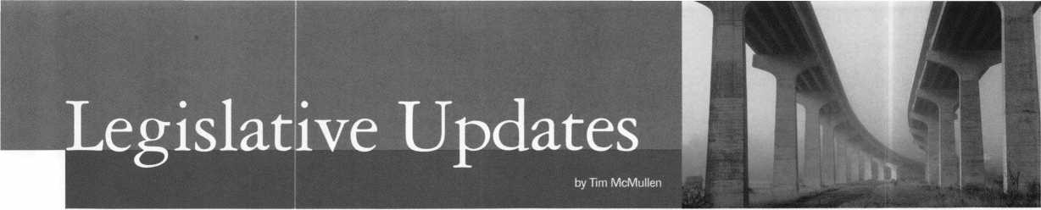

A TALE OF TWO CITIES

This is the story of two American cities, and how the Legislative Action Network plays such an important role for ALOA. Des Moines and Indianapolis are similar in many ways. The biggest cities for their respective states, they also house their seat of government. This legislative session, two alarm licensing bills were introduced that on their face seem perfectly harmless. However, upon closer inspection, Indiana Senate Bill 53 didn’t quite define what an alarm system is (to be determined later by the Alarm Board). Likewise, Iowa House File 203 (later HF 310) defined an alarm business as including access control and CCTV. These potentially dangerous bills had to be addressed by the membership in their respective states - immediately.

The first thing ALOA does is notify the chapter or state association of the bill, calling for the membership to take immediate action. The second place we turn to is the Legislative Action Network (LAN). This is a group of members who have generously donated their time by simply saying, “Hey, when there’s a bill in my state that affects our industry, give me a call and I’ll help out in any way I can, be it a phone call, fax or letter.” That’s all they are asked to do, but they play a vital role in any legislative grassroots campaign because they will do it immediately. And the nature of legislation is that it requires prompt action. Finally, a blast-fax or letter is sent to all members in that state calling them to also take action.

In Indiana, ALOA has over a dozen LAN members. With a quick blast-fax and a couple of phone calls, we had the ball rolling. With support from the Southern Indiana, Central Indiana and Northern Indiana ALOA chapters, enough people made calls to keep the bill in committee. It was quick, it was cost-effective and it worked!

On the other hand, ALOA has no LAN members in Iowa. This made the process extremely difficult, especially because this bill was quickly making it’s way through the Iowa House. Luckily we were able to work with Richard Malmquist and the Iowa Locksmith Asso­ciation who were extremely helpful in getting the word out.

However, there was still a lapse in time, and the bill almost made it out of committee without being amended (see Legislative Update below).

Currently, there are over 140 LAN members, but not every state is covered. States without LAN members include:

Alaska Idaho South Dakota

Connecticut Maine Vermont

Delaware North Dakota West Virginia

Hawaii Nevada

Iowa Rhode Island

In order for ALOA to survive legislatively, we must have members who are willing to come forward and at least make a phone call or go to an occasional hearing. On your membership renewal, there is a box to check for joining the LAN or simply fill out the form on page 42 and mail it. To cover mailing and blast fax costs, we are only asking for a small donation of $24.95. However, for your generosity you will get an official LAN lapel pin and invited to a special LAN reception at convention. This has been a good year for ALOA, but continued support is needed. Remember, “It was the best of times, it was the...”

LEGISLATIVE UPDATES

ARIZONA H2493

AUTHOR: Gerard, et al

SUMMARY: Relates to locksmiths; relates to work orders; relates to

information retention.

STATUS: 01/12/1999 INTRODUCED. 03/08/1999 passed

House. 03/10/1999 to SENATE Committee on COMMERCE.

CONNECTICUT S112

AUTHOR: Gaffey

SUMMARY: Requires the licensing of locksmiths.

STATUS: 01/11/1999 To JOINT Committee on GENERAL

LAW. 02/24/1999 Drafted by Committee.

IOWA H310 (Formally H203)

AUTHOR: Committee on State Gov

SUMMARY: Provides for the mandatory licensure of alarm system

businesses by the department of public safety, and makes many of the provisions of Code chapter 80A, which applies to the licensing.

STATUS: 02/18/1999 INTRODUCED. 02/18/1999 In

HOUSE. Formerly HOUSE File 203. 02/25/1999 In HOUSE. Filed Amendment No. 1036 (excludes locksmiths who do access control not connected to an alarm panel that requires a response). 03/01/1999 In HOUSE. Adopted Amendment No. H 1036.

03/01/1999 Passed HOUSE. To SENATE. 03/02/1999 To SENATE Committee on STATE GOVERNMENT.

ILLINOIS H1296

AUTHOR: Saviano

SUMMARY: Makes technical changes in the Section concerning

unlawful acts in the Private Detective, Private Alarm, Private Security and Locksmith Act of 1993

STATUS: 02/17/1999 INTRODUCED: 02/17/1999 To

HOUSE Committee on RULES. 02/18/1999 To HOUSE Committee on EXECUTIVE. 02/25/1999 From HOUSE Committee on EXECUTIVE: Do pass. 02/25/1999 In HOUSE. Placed on Calendar Order of Second Reading. 02/26/1999 Rereferred to HOUSE Committee on EXECUTIVE. 03/05/1999 Referred to HOUSE Committe on RULES.



Keynotes

**April 1999**

ILLINOIS H620

AUTHOR:

SUMMARY:

STATUS:

ILLINOIS H621

AUTHOR:

SUMMARY:

STATUS:

ILLINOIS S212

AUTHOR:

SUMMARY:

STATUS:

ILLINOIS S452

AUTHOR:

SUMMARY:

STATUS:

INDIANA S53

AUTHOR:

SUMMARY:

Capparelli, Saviano

Amends the Private Detective, Private Alarm, Private Security, and Locksmith Act of 1993; deletes the phrase “at premises, vehicles, safes, vaults, safe deposit boxes, or automatic teller machines” from the definition of “the practice of locksmithing”; effective immediately.

02/04/1999 INTRODUCED. 02/10/1999 To HOUSE Committee on EXECUTIVE. 03/04/1999 From HOUSE Committee on EXECUTIVE: Do Pass.

Capparelli, Saviano

Amends Private Detective, Private Alarm, Private Security, and Locksmith Act of 1993; provides that police, fire or other municipal employees may open a lock in a life-threatening situation or when the location of a vehicle creates a danger to the public; effective immediately.

02/04/1999 INTRODUCED. 02/05/1999 To HOUSE Committee on RULES. 02/10/1999 To HOUSE Committee on EXECUTIVE. 03/04/1999 From HOUSE Committe on EXECUTIVE: Do pass.

STATUS: 12/09/1998 PREFILED. 12/09/1998 To SENATE

Committee on PUBLIC POLICY 01/06/1999 INTRODUCED. 01/06/1999 To SENATE Committee on PUBLIC POLICY

MASSACHUSETTS S545

AUTHOR: Jajuga, et al

SUMMARY: Establishes a program with the Department of

Housing and Community Development to retrofit windows with security bars.

STATUS: 01/06/1999 INTRODUCED. 01/06/1999 To

JOINT Committee on HOUSING AND URBAN DEVELOPMENT.

MISSOURI H303

AUTHOR: Dolan

SUMMARY: Regulates alarm businesses and agents; provides for

certificates of registration; creates the Missouri Private Security Alarm Business Registration Board; provides duties of the Board and the Attorney General; provides misdemeanor penalties for certain violations.

STATUS: 01/11/1999 INTRODUCED. 01/25/1999 To

HOUSE Committee on PROFESSIONAL REGISTRATION AND LICENSING.

Burzynski

Makes a technical change.

02/03/1999 INTRODUCED. 02/03/1999 To SENATE Committee on RULES. 02/17/1999 To SENATE Committee on LICENSED ACTIVITIES. 02/26/1999 In SENATE Committee on LICENSED ACTIVITIES: Postponed in committee.

Burzynski

Amends the Private Detective, Private Alarm,

Private Security, and Locksmith Act of 1993; provides that an agency may employ a person under the act if the person possesses a valid permanent employee registration card or if the person has a valid license under the Act.

02/18/1999 INTRODUCED. 02/18/1999 To SENATE Committee on RULES. 02/24/1999 To SENATE Committee on LICENSED ACTIVITIES. 03/11/1999 Passed SENATE. To HOUSE.

Meeks

Requires a person who operates a business that installs, repairs, or services an alarm system to be licenses; establishes an alarm system board; establishes licensure and registration requirements for the regulation of alarm system contractors and their employees; requires employees of an alarm system contractor to be registered and have identification cards; staggers the terms of the initial appointments to the board.

NEVADA A115

AUTHOR: Committee on Commerce and La

SUMMARY: Extends date of expiration of permit to operate as

locksmith or safe mechanic.

STATUS: 02/03/1999 INTRODUCED. 02/04/1999 To

ASSEMBLY Committee on COMMERCE AND LABOR. 02/24/1999 From ASSEMBLY Committee on COMMERCE AND LABOR: Do pass. 02/26/1999 Passed ASSEMBLY. To SENATE. 03/08/1999 To SENATE Committee on COMMERCE AND LABOR: Do pass.

NEW YORK A2099

AUTHOR: Towns, et al

SUMMARY: Allows for a 10% credit against income tax for

businesses in Kings County which install security systems at their businesses.

STATUS: **01/20/1999** INTRODUCED. **01/20/1999** To

ASSEMBLY Committee on WAYS AND MEANS.

NEW YORK A3889

AUTHOR: D’Andrea, et al

SUMMARY: Provides that a taxpayer 65 years of age or over shall be

allowed a credit against personal income tax for the purchase and installation of a security device in his principal residence located within the state; provides that such credit is limited to 50% of the expenditure not to exceed a maximum of $400.

STATUS: 02/04/1999 INTRODUCED. 02/04/1999 To

ASSEMBLY Committee on WAYS AND MEANS.

**April 1999**

***Keynotes* | 41**

NEW YORK A4560

AUTHOR: Dinowitz, et al SAME AS: S25 30

SUMMARY: Makes it a class A misdemeanor to knowingly

possess equipment used to make duplicate keys under circumstances evidencing intent to use such devices to unlawfully enter or operate a motor vehicle.

STATUS: 02/11/1999 INTRODUCED. 02/11/1999

To ASSEMBLY Committee on ECONOMIC DEVELOPMENT.

NEW YORK A 515

AUTHOR: Kaufman, et al

SUMMARY: Provides that class A multiple dwellings have eight or

more apartments erected or converted prior to 1968, must have automatic self-closing and self-locking doors at every entrance from the street, roof, passageway, courtyard, cellar or other entrance; excludes main entrance halls and lobbies if equipped with automatic self-locking doors.

STATUS: 12/31/1998 PREFILED. 12/31/1998 To ASSEMBLY

Committee on HOUSING. 01/06/1999 INTRODUCED. 01/06/1999 To ASSEMBLY Committee on HOUSING.

NEW YORK A718

AUTHOR: Hill, et al

SUMMARY: Permits a state income tax deduction for home security

devices, including but not limited to exterior lighting, installed by the owner occupant of a one, two or three family home for an amount not to exceed $500.

STATUS: 01/06/1999 INTRODUCED. 01/06/1999 To

ASSEMBLY Committee on WAYS AND MEANS.

NEW YORK A5684

AUTHOR: Colton, et al

SUMMARY: Authorizes city with a population of 1,000,000 or

more to allow credit, by local law or ordinance, against personal income tax imposed by such city, for expenses of providing security for the home, provided such structure is a 1, 2 or 3 family owner occupied residence.

STATUS: 03/01/1999 INTRODUCED. 03/01/1999 To

ASSEMBLY Committee on CITIES.

TEXAS H1365

AUTHOR: Burnam

SUMMARY: Relates to security bars on residential dwellings.

STATUS: 02/11/1999 INTRODUCED. 02/15/1999 To

HOUSE Committee on PUBLIC SAFETY.

VIRGINIA H1995

AUTHOR: Keating

SUMMARY: Clarifies the definition of electronic security equipment

by eliminating the reference to radio frequency-based technology.

STATUS: 01/19/1999 INTRODUCED. 01/19/1999 To

HOUSE Committee on MILITIA AND POLICE. 02/03/1999 From HOUSE Committee on MILITIA AND POLICE: Reported with amendment. 02/05/1999 Committee amendment adopted on HOUSE floor. 02/05/1999 Engrossed by HOUSE as amended. 02/06/1999 Passed HOUSE. To SENATE. 02/08/1999 To SENATE Committee on GENERAL LAWS. 02/10/1999 From SENATE Committee on GENERAL LAWS: Reported favorably. 02/12/1999 Passed SENATE. Signed by GOVERNOR.

LEGISLATIVE ACTION NETWORK

I am interested in: [HI Working on Legislative Issues (ZH Fundraising EZI Gathering/Giving Information

Name:

ALOA member number:

Company:

Company Address:

City, State ZIP:

Home Address:

City, State ZIP:

Telephone:

Fax:

E-mail:

£3 Mail this completed form with $24.95 to:

LEGISLATIVE ACTION NETWORK, Associated Locksmiths of America, 3003 Live Oak Street, Dallas, TX 75204.

**42 | *Keynotes***

**April 1999**

Keynotes

Authors



Dept J

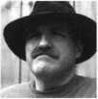

Paul Chandler,

CRL, is the manager of the Electronic  
Security Department for IDN-  
ACME in Houston, TX. He was  
also "Keynotes Author of the Year”  
for 1998.



« Claire L. Cohen,

the second woman to become a CML,  
has been in locksmithing since 1977  
and has been writing articles for  
Keynotes since 1987.

I Sal Dulcamaro,

CML, has been in the locksmith  
business for over 23 years. He is the  
president of All Pro Security, Inc. in  
Michigan and has been an ALOA  
member for 16 years. A past president  
of the Locksmith Security Association  
of Michigan. Sal currently serves as  
editor of the association newsletter. He  
was named "Keynotes Author of the  
Year” for 1996 and 1997.



Mike Emery is the

Editor ^/Keynotes and a freelance  
music, film and real estate uriter.

Michael Eerrill is

a third generation locksmith,  
located on the island of Nantucket  
in Massachusetts. His company  
name is Island Locksmith. He can  
be reached for comment by writing  
directly to Island Locksmith,

25 Sesapana Road, Nantucket, MA 02554 or by writing through this magazine.

Patanya Johnson is ALOA’s Communications Assistant

Tim McMullen

oversees legislative affairs for ALOA.

He is a graduate of the District of  
Columbia School of Law and has  
an extensive background in  
legislative work.



THERE ARE 50 REASONS WHY YOU SHOULD JOIN US THIS YEAR



THE FIRST 49 ARE ALREADY OVER. DON’T MISS THIS ONE!

GPL A 50th Anniversary Convention

September 15th-19th, 1999  
Radisson Philadelphia International Airport

Free Clinic

Key Squares Breakfast  
Hands-on Training Classes  
President’s Reception

Product Exhibit  
Lock Picking Contest  
Black Tie Awards Banquet  
Friday Night Social

For Further Information:

Reservations Exhibitors

Jack Magee Don Amole

Phone: 609-384-1538 Phone: 215-288-5588

Fax: 609-845-3024 Fax: 215-288-2511

Or visit our website at: [www.gpla.org](http://www.gpla.org)

**April 1999**

Keynotes

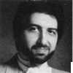

NA\\£ **T M AT**

The sound of music. It’s a wonderful thing, isn’t it? From classical to country, to rock n’ roll and jazz, nothing can compare to the feelings certain tunes inspire. Keynotes would like to show its appreciation of the fine arts by sending one lucky reader to the Cincinnati Symphony. The catch? Just name that tune!

Below are some lyrics and clues that pertain to popular songs. If you can name the title of the song you’ll qualify to win two premium symphony tickets.

**^.e© 1? tVOC'**

1) Bob Dylan was never a great singer, but some people considered him one of the best songwriters ever. Can you name the Dylan song that contained these lyrics?:

“She was married when we first met, soon to be divorced.

I helped her out of a jam, I guess, but I used a little too much force.

We drove that car as far as we could, abandoned it out west.

Split up on a sad dark night, both agreeing it was best.”

X) Name the state song that goes like this:

“You’re the state of natural wonders I’m longing to explore.

Rich in history and tradition. A queen gave you her name.

You’re the birthplace of mighty men bearing presidential fame.”

*^) This Herman’s Hermits tune drove some people crazy. Literally. It may well be the worst song ever recorded, but it was a hit. It detailed the life of a certain king.

Can you “name that monarch?” The lyrics went like this:

“I got married to the widow next door. She’s been married seven times before.

And every one was an Henry (Henry). She wouldn’t have a Willy or a Sam (no Sam). I’m her eighth old man...”

£\) Before he starred in the remake of The Jazz Singer, Neil Diamond carved a living out of songwriting. This is one of his most popular. Name this tune!:

“Me and you are subject to the blues now and then.

But when you take the blues and make a song. You sing them out again.”

Send your answers to:

ittYlWTSS

APP«E£-FATi©N **QSJil**

3003 Live Oak Dallas, TX 75204 or fax to: 214.827.1810

l_J TE2 IS Please u start 1 I extend my subsi

J 3 YEARS (includes 36 issues, 3 FREE Annual Directory* issues)

USA $90.00

J 2 YEARS (includes 24 issues, 2 FREE Annual Directory* issues)

USA $64.00 Canada $93.00 International (air) $185.00

J 1 YEAR (includes 12 issues, 1 FREE Annual Directory* issue)

USA $41.00 Canada $52.00 International (air) $100.00

International (surface) $119.00

International (surface) $65.00

’Comprehensive guide to industry manufacturers, distributors, products and services.

CARD INVALID UNLESS COMPLETE DATA IS GIVEN

You must indicate your locksmithing affiliation below:

1. Are you a locksmith or an individual involved in locksmithing? Qyes Qno
2. Your position is: QOwner/Pres. Q3 Employee Q6 Student Q9 Other (specify)

3 Business classification (check one only): **a** □Locksmith Shop **b** QHardware

c Q Wholesaler/Distributor d Q Manufacturer e Q Security or Maintenance

1. □ Consultant 3 Q Industrial 5Q Government
2. □ Commercial 4 Q Institutional 6 Q Police

g Q Architect/Specifier z Q Other (specify)

4. Are you involved in purchasing or influencing the purchase of locksmith products?

□yes Qno

Name:.

Company:. Address: _

City: _

. State:.

-Zip:_

Phone: _

_ Fax:.

Payment (US FUNDS ONLY): QMoney order □Charge Card □Check#:

Complete For Charge Orders Only: QVISA □ Master Card □American Express

Account # :Exp. Date:

Signature:

IM9

Send payment to: Locksmith Publishing Corp. • 850 Busse Flwy. • Park Ridge, IL 60068 • Phone:(847)692-5940 • Fax (847) 692-4604 • Website: [www.lpc.simon-net.com](http://www.lpc.simon-net.com)

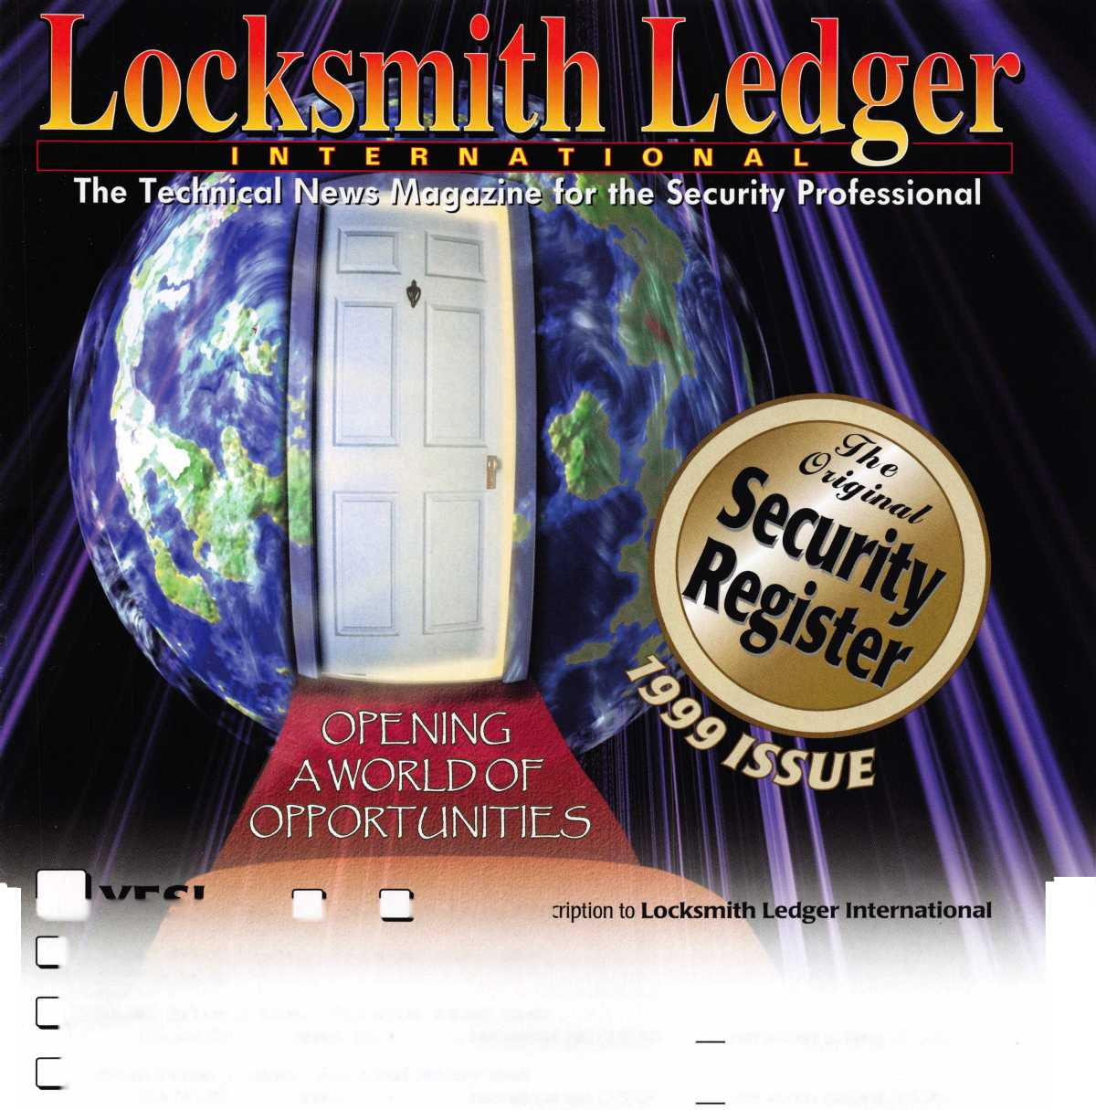

**JULY 25—31**



Into classes, into networking,  
into the latest products.

This year, don't miss the best  
locksmithing trade show and education  
event of 1999-the ALOA Convention  
and Security Expo. Discover the city  
that boasts Fountain Square, riverboats,  
water parks and a breathtaking  
river view from Mt. Adams.

See you at the pool (the talent pool).

For more info, call 800.532.2562  
or check out [www.aloa.org](http://www.aloa.org)

